Islamic Theology—1.2B
Discuss the Islamic beliefs regarding:
- the Koran
- the Hadith
- Muhammed

The Muhammad cartoons crisis began after 12 editorial cartoons, most of which depicted the Islamic prophet Muhammad, were published in the Danish newspaper Jyllands-Posten on 30 September 2005. The newspaper announced that this publication was an attempt to contribute to the debate about criticism of Islam and self-censorship. Muslim groups in Denmark complained, and the issue eventually led to protests around the world, including violent demonstrations and riots in some Muslim countries.
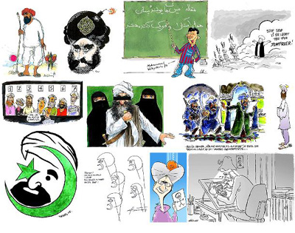
Islam has a strong tradition of aniconism, and it is considered highly blasphemous in most Islamic traditions to make a picture of the prophet Muhammad. This, compounded with a sense that the cartoons insulted Muhammad and Islam, offended many Muslims. Danish Muslim organisations that objected to the depictions responded by petitioning the embassies of Islamic countries and the Danish government to take action in response, and filed a judicial complaint against the newspaper, which was dismissed in January 2006. After the Danish government refused to meet with diplomatic representatives of the Muslim countries and would not intervene in the case, a number of Danish imams visited the Middle East in late 2005 to raise awareness of the issue. As a result, the issue received prominent media attention in some Muslim countries, leading to protests across the world in late January and early February 2006. Some escalated into violence resulting in more than 200 reported deaths, attacks on Danish and other European diplomatic missions, attacks on churches and Christians, and a major international boycott. Some groups responded to the outpouring of protest by endorsing the Danish policies, launching "Buy Danish" campaigns and other displays of support. The cartoons were reprinted in newspapers around the world both in a sense of journalistic solidarity and as an illustration in what became a major news story.

