John Wycliffe - A Voice Speaks Out in England (1320-1384)

- An __________________, Wycliffe studied at _____________ and later became a famous professor at the same place
- Spoke out against the corruption in the ___________, saying that sin in a clergyman’s life disqualifies him for the position
- As the Great Schism unfolded, Wycliffe began to speak out against the __________, eventually denouncing the pope and calling him the antichrist. He called for reform in the papacy and advocated that the papacy give up its _______________ power and return to poverty and humility. He said all men are ________ in God’s eyes
- Wycliffe came to reject the following beliefs and practices: pardons, _______________, pilgrimages, the worship of images and ___________, the treasury of merits laid up at the reserve of the pope, and, perhaps most importantly of all, the doctrine of __________________________________.
- Wycliffe also believed that the __________________ should be the rule of life, so he pushed for the translation of the Bible into the common language. He and his followers translated the Bible into the ______________ language and attempted to get into the hands of common people.
- Wycliffe’s followers were called ________________.
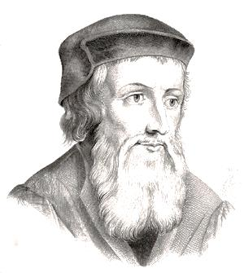
- Although he made many enemies in his life, Wycliffe died a natural death in 1384. However, he was condemned as a heretic thirty years later, at which time his bones were dug up, burned, and then thrown in the river.
- Wycliffe is often called the “____________________________________.”

