John Wycliffe - A Voice Speaks Out in England (1320-1384)

- An Englishman, Wycliffe studied at Oxford and later became a famous professor at the same place
- Spoke out against the corruption in the clergy, saying that sin in a clergyman’s life disqualifies him for the position
- As the Great Schism unfolded, Wycliffe began to speak out against the pope, eventually denouncing the pope and calling him the antichrist. He called for reform in the papacy and advocated that the papacy give up its temporal power and return to poverty and humility. He said all men are equal in God’s eyes
- Wycliffe came to reject the following beliefs and practices: pardons, indulgences, pilgrimages, the worship of images and saints, the treasury of merits laid up at the reserve of the pope, and, perhaps most importantly of all, the doctrine of transubstantiation
- Wycliffe also believed that the Scripture should be the rule of life, so he pushed for the translation of the Bible into the common language. He and his followers translated the Bible into the English language and attempted to get into the hands of common people.
- Wycliffe’s followers were called Lollards
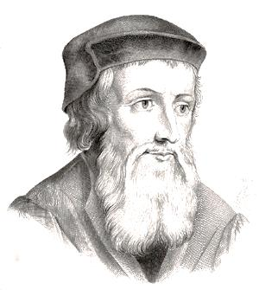
- Although he made many enemies in his life, Wycliffe died a natural death in 1384. However, he was condemned as a heretic thirty years later, at which time his bones were dug up, burned, and then thrown in the river.
- Wycliffe is often called the “Morning Star of the Reformation”

