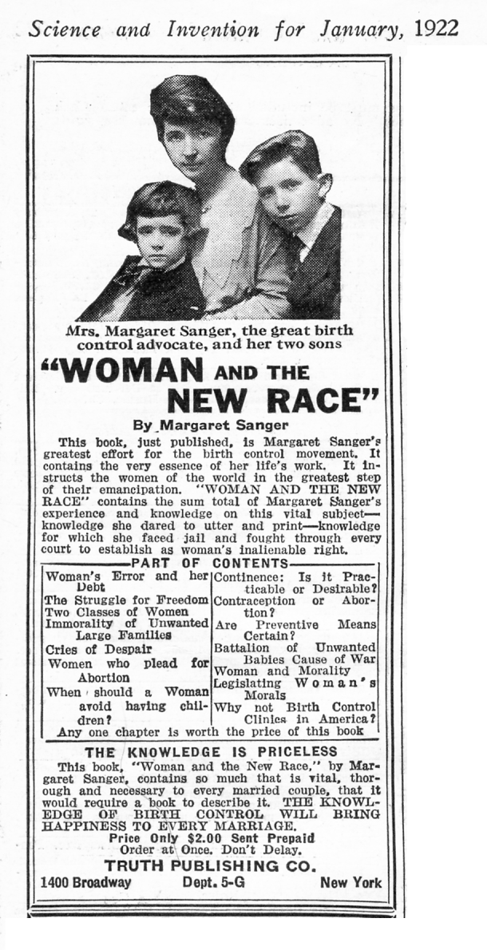
Margaret Sanger:
As part of her efforts to promote birth control, Sanger found common cause with proponents of eugenics, believing that they both sought to "assist the race toward the elimination of the unfit."^{[84]} Sanger was a proponent of negative eugenics, which aims to improve human hereditary traits through social intervention by reducing the reproduction of those who were considered unfit.^{[85]} Sanger's eugenic policies included an exclusionary immigration policy, free access to birth control methods and full family planning autonomy for the able-minded, and compulsory segregation or sterilization for the profoundly retarded.^{[86][87]} In her book The Pivot of Civilization, she advocated coercion to prevent the "undeniably feeble-minded" from procreating.^{[88]} Although Sanger supported negative eugenics, she asserted that eugenics alone was not sufficient, and that birth control was essential to achieve her goals.^{[89][90][91]}

Peter Singer:

Animal Liberation[edit]
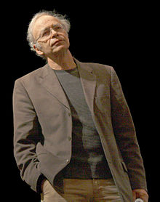
Published in 1975, Animal Liberation^{[15]} has been cited as a formative influence on leaders of the modern animal liberation movement.^{[16]} The central argument of the book is an expansion of the utilitarian idea that "the greatest good of the greatest number" is the only measure of good or ethical behaviour. Singer believes that there is no reason not to apply this to other animals, arguing that the boundary between human and ‘animal’ is completely arbitrary. There are more differences between a great ape and an oyster, for example, than between a human and a great ape, and yet the former two are lumped together as ‘animals’ whilst we are ‘human’.
In particular, he argues that while animals show lower intelligence than the average human, many severely intellectually challenged humans show equally diminished, if not lower, mental capacity, and that some animals have displayed signs of intelligence sometimes on par with that of human children. Singer therefore argues intelligence does not provide a basis for providing nonhuman animals any less consideration than such intellectually challenged humans.^{[17]}

Euthanasia and infanticide
Consistent with his general ethical theory, Singer holds that the right to life is essentially tied to a being's capacity to hold preferences, which in turn is essentially tied to a being's capacity to feel pain and pleasure. Critics such as Laing hold that this view is subject to charges of inconsistency, equivocation and contradiction.
Similar to his argument for abortion, Singer argues that newborns lack the essential characteristics of personhood—"rationality, autonomy, and self-consciousness"^{[24]}—and therefore "killing a newborn baby is never equivalent to killing a person, that is, a being who wants to go on living."^{[25]}

