Three Views of the Mind
 | Naturalist  (Secular Humanism, Marxism, Postmodernism) | New Age | Christian
What is the mind? | Purely physical processes—electrical impulses created by chemical reactions | The spiritual ability to connect to the cosmic life force/higher consciousness of the universe | The part of man that reflects the image of God; rooted in the physical but at the same time extending into the spiritual
What is the purpose of the mind? | No ultimate purpose; perpetuating the species | To connect with the cosmic life force through one’s own inner divinity; to tune into the frequency of the higher energy of the universe and harmonize with it | To fellowship with the Creator and to sub-create for His glory
What happens to the mind at death? | It ceases/disappears | It is freed to be joined with the cosmic life force | It continues to exist; it is held accountable for its choices; eventually rejoins the body
A picture for “the mind” | 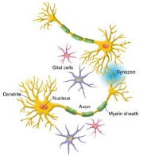  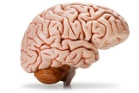 | 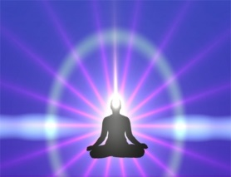 | 