Worldviews
Mr. Myers

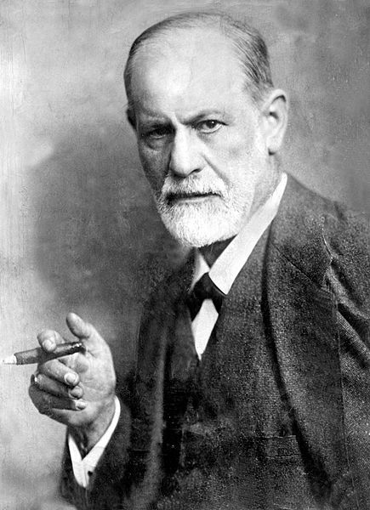
Psychology: Overview of Modern Psychology
- Freud
- Considered religion to be a form of neurosis and to be the source of many
if not most mental and emotional problems
- Developed a rather bizarre theory that sexual desire controls
basically all human behavior
- Psychoanalysis, Oedipus complex, stages, id/ego/superego,
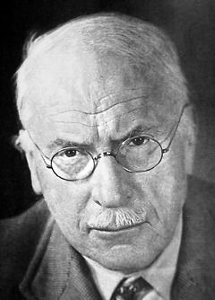
- The subconscious an iceberg; role of dreams, slips,
- A human being is pretty much formed by age 5 or 6

- Carl Jung
- Analytic psychology, collective unconscious, archetypes

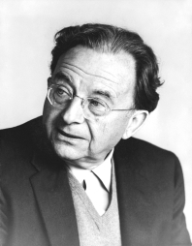
- Erich Fromm
- Unconditional love; the answer to our emotional and mental problems is unconditional love, that is, to love oneself; this love does not come from God, however; in fact, God is just a “childish illusion” in his words

- Abraham Maslow
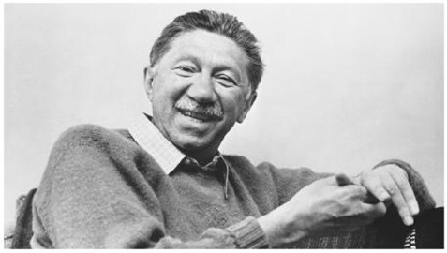
- Hierarchy of needs: bodily needs, safety needs, love needs, esteem needs, self-actualization needs
- Believed in the innate goodness of each person at the core and thought that one of the primary obstacles to people achieving self-actualization is the teaching that man’s nature is fallen and contains evil

- Arthur Janov
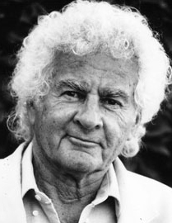
- The primal scream therapy--all of a person’s painful experiences drains into a primal pool of pain and then that person cuts that part of himself off to escape the pain; the only way to overcome that handicap is to experience the infantile suffering again and then to work through it by expressing the pain, sometimes in a literal scream.

- Ivan Pavlov, J.B. Watson, and B.F. Skinner
  - Behaviorism: the idea that people can be trained in whatever way desired by strictly physical stimuli
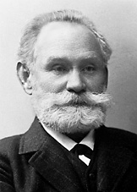
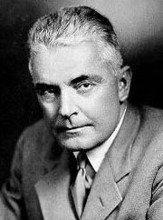
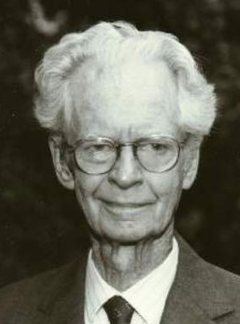
  - “Give me a dozen healthy infants, well-formed, and my own specified world to bring them up in and I’ll guarantee to take any one at random and train him to become any type of specialist I might select—doctor, lawyer, artist, merchant-chief and, yes, even beggar-man and thief, regardless of his talents, penchants, tendencies, abilities, vocations, and race of his ancestors.” (1930) –J.B. Watson

Maslow’s Heirarchy of Needs
