Kendall Myers
August 2012
Ideas for physical science class:
- Work hard to connect the concepts to daily experiences and to apply them to life somehow
- Try to do one demonstration or project per week
- Have students work in teams to make an egg launcher
- Have a bridge-building contest with popsicle sticks
- Teams of two make their own electric motor
Note: Because of copyright issues, the following projects only appear as blurbs. Visit the links to view the entire project.

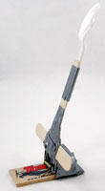
Mousetrap Marshmallow Catapult
Get ready to launch marshmallows across the room with the power of a mousetrap! Print out our Marshmallow Catapult instruction sheet with step-by-step pictures.
View the plan at http://www.hometrainingtools.com/a/mousetrap-physics-newsletter

Balloon Jet
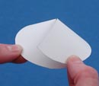
This is a very simple rocket that demonstrates the most basic principle of rocketry: how pressurized gas creates thrust.
View the plan at http://www.hometrainingtools.com/a/space-exploration-newsletter

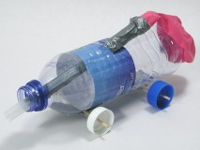
Balloon Rocket Car + Video
<<Force & Motion Products
A rocket is simply a chamber filled with pressurized gas. A small opening called a nozzle allows the air to escape, causing thrust that propels the rocket. You can demonstrate this when you blow up a balloon and let it go without tying it off. The balloon will fly through the air as all the air inside escapes.
View the plan at http://www.hometrainingtools.com/a/balloon-rocket-car-project/

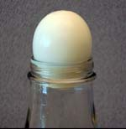
Hard-boiled egg in a bottle experiment
View the plan at http://www.hometrainingtools.com/a/egg-in-bottle-project

Build a Rubber Band Car
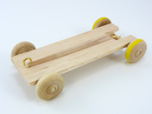
A stretched rubber band is a great source of elastic potential energy. When released, that energy is converted to kinetic (motion) energy as the rubber band snaps back to its original size and shape. How can we tap into this energy source? Let's try using it to power a small car! (Adult supervision required.)
View the project at http://www.hometrainingtools.com/a/rubberband-car-project

