Physical Science:
Matter and Energy

2015-2016 Syllabus

Mr. Myers

I. Course Objectives:

- To investigate a wide array of scientific fields of study - meteorology, oceanography, chemistry, geology, electricity, magnetism, light, and physics
- To lay a good foundation for further study in science, such as chemistry and physics
- To connect the ideas of physical science to our daily lives
- To enjoy and appreciate the beauty, grandeur, and order of the world

II. Course Requirements:

- Completion of daily assignments, quizzes, and tests
- Memorization of core elements from the Periodic Table of the Elements
- Make an egg launcher and compete it against everyone else’s egg launcher
- Make an electric motor
- Apply newly acquired knowledge to observation, investigation, and experimentation

III. Grading

- Quizzes 20%
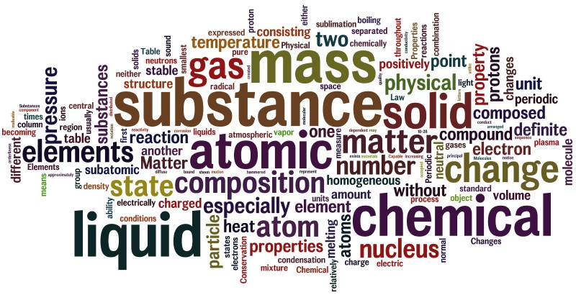
- Tests 80%

