The countries I used for my “Countries of the World” theme were chosen thanks to a yard sale. A lady had done an Olympic-themed party and was selling her banner that had forty different countries’ flags in it. I chose to hang that banner in my room and use those forty countries.
Each week of the school year, we focused on one country. We looked for it on the map, prayed for it (I used the book Operation World for prayer requests.), learned a few words in their language, handled souvenirs from the country (amazing how many things from around the world you can borrow if you have traveling friends), and did an art/craft project connected to the country.
I am sharing in this document my list of art/craft projects. I didn’t find projects for every country, but this is a good start. Separately, I will also share my small posters of each country’s language. Hopefully I have them accurate. They were based off of lots of internet research.
During this school year, I did bulletin boards based on each continent. I will share photos of them, as well.
You can download and print booklets for children about children in persecuted churches from Voice of the Martyrs. https://www.kidsofcourage.com/
This series of books is full of facts and crafts: https://www.amazon.com/New-Trip-Around-World-Grades/dp/160418034X/ref=sr_1_8?keywords=around+the+world+activity+book+learning+resources&qid=1563641230&s=gateway&sr=8-8
I printed a whole bunch of amazing free pictures from Teachers Pay Teachers for my bulletin boards: https://www.teacherspayteachers.com/Product/Mother-and-Child-around-the-World-Cards-1835631
Art/Craft Projects
Malaysia – Foil Elephants
A fun craft made with cardboard, foil, glue, and paint. This craft could also be used for other countries that have lots of elephants. Go to this website for instructions:
https://kidworldcitizen.org/try-this-gorgeous-asian-elephant-craft/

Albania – Cardboard Loom Weaving
This country is known for its beautiful weaving.
You can buy cardboard looms or make your own. The easiest way to explain this craft is to say “look it up online!”

Morocco – Mosaic Project
There are many beautiful mosaics in Morocco.
I have done different mosaic projects for this. Feel free to research and choose one that works for you.

Costa Rica – Blue Morpho Butterfly
If you do this project on small paper plates the butterfly will be almost actual size!
https://kidworldcitizen.org/make-a-tropical-blue-morpho-butterfly/

Columbia – Discuss Bellavista Prison and find a prison ministry to bless with cards
This link takes you to the book that has the story of the spiritual transformation of the Bellevista prison, once the most bloody and violent prison in the world.
https://www.amazon.com/Lord-BellaVista-David-Miller/dp/0281051283

Jordan – Salt Painting
This is the home of the Dead Sea…therefore a salty sort of art project.
https://artfulparent.com/raised-salt-painting/

Canada – Tlingit Whale Project
Students make a multi-colored whale out of construction paper.
https://thecraftyclassroom.com/crafts/native-american-crafts-for-kids/tlingit-crafts-for-kids/tlingit-art-project/

Suriname – Monkey Craft
This craft can be used for any country that has lots of monkeys. The template is in a separate document.

Greece – Paint a watercolor Greek urn
Find a template for a Greek urn here:
www.theimaginationbox.com/uploads/1/2/2/2/12222292/urn_template2.pdf

Portugal – Big Mouth Fish
They do a lot of fishing in Portugal!
https://micador.com.au/blogs/ideas/2018/Aug/16/big-mouth-fish
Czech Republic – Bake gingerbread cookies
NOTES:
*Mix dough ahead of time and divide into balls.
*Each pair of students needs a ball of dough, and two pieces of parchment paper.
*Ask moms for rolling pins and two cookie cutters.
*Mix icing ahead of time and put in small bags.
*Roll
*Cut
*Put on pans
*Recess while baking (in place of last recess)
*Decorate and eat while reading a story

Kuwait – Camel Silhouette
The background is pieces of torn construction paper. We cut out a camel silhouette and glued it on.
Here is a website where you can download a camel silhouette:
https://silhouettegarden.com/download/camel-silhouette/

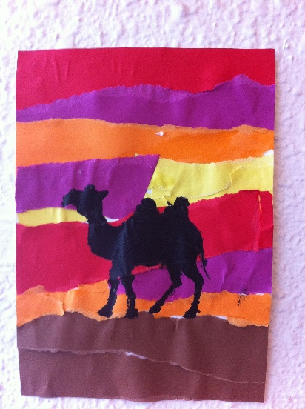

Finland – Finnish Star
https://www.acherryontop.com/articles/Finnish-Star-5021
Israel – Flag Painting
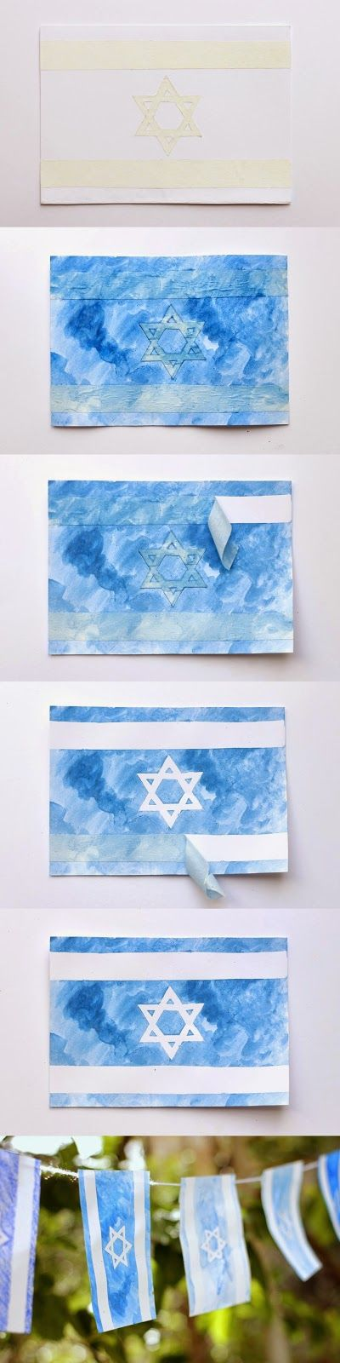
- Draw straight lines and star lines.
- Tape straight lines with regular masking tape, star lines with fine tape.
- Paint with watercolors.
- Allow to dry.
- Remove tape.

Sweden – Woven Heart Basket
https://www.northpole.com/CraftCottage/scandinavian-woven-hearts

Russia – City Silhouette
https://www.activityvillage.co.uk/russian-cityscape-silhouette

Indonesia – Batik Curtains
I sewed plain white curtains for my classroom at the beginning of the year, then we did this craft partway through and put our beautiful curtains back up. My students worked in small groups; one group for each curtain.
https://www.firstpalette.com/craft/glue-batik.html

Ireland – Stick Lighthouse
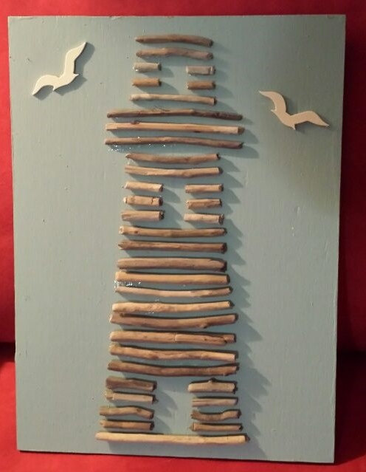
Step 1: Draw Lighthouse and all desired background
Step 2: Break sticks to fit
Step 3: Glue sticks in place
SUPPLIES NEEDED: STRAIGHT, THIN STICKS FROM HOME!!!

North Korea – Yut-Nori Board Game
http://www.littleseoulster.com/how-to-make-and-play-yut-nori/

Italy – Spaghetti/Marshmallow Towers
There are many variations on this challenge. I divided my class into groups of 3 or so and gave each group a box of spaghetti and bag of mini marshmallows. I then gave them a set length of time in which to build the tallest possible tower. Why with Italy? The Leaning Tower of Pisa, of course! It is fun to spend some time studying this tower. Oh, and if you do this in your classroom you will still be sweeping pieces of spaghetti next school year (even after multiple sweepings, whole school cleaning, and carpet cleaners!). Maybe I’ll do it outside next time.
Editor’s note: toothpicks also work well and would be less mess than spaghetti.

Philippines – Tapatan Game
https://www.whatdowedoallday.com/tapatan/

Saudi Arabia – Sandpaper Rugs
Saudi Arabians make amazing rugs. I showed my students some internet pictures of examples, then they each were given a piece of sandpaper and used crayons to design their own rug. The texture is really cool for this project. And, if you have off brand crayons around that don’t color well, this is a great project for them.

Hungary – Name Craft
In Hungary there seem to be certain names that you can or cannot name your child, so we did a craft using our names for this country.
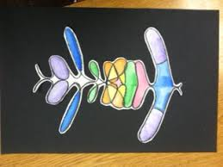
There are many ideas online. This is just one example.

Honduras – Scarlet Macaw Drawing
We followed these drawing instructions and then colored them with oil pastels to capture some of their brilliant coloring.
https://www.artwithchildren.net/p/blog-page_2.html

China – Paper Cuts
https://www.activityvillage.co.uk/chinese-paper-cuts
The one we used was the simple black and white one of the monkey.

United Kingdom – Origami Scottie Dog and play “What’s the Time, Mr. Wolf?”
https://origami.me/scottie/
https://www.wikihow.com/Play-What%27s-the-Time-Mr-Wolf

