Lesson 2 Teacher’s Guide

Clothing or equipment
helm
helmet
surcoat
overcoat
breeches
short pants
long hose
like tights
pointed shoes
showed wealth or importance
cotte
undergarment with long sleeves similar to a t-shirt. Men wore them to the hip but women wore them full length
hood with a cape

Heraldic terms vocabulary
gules
red
fesse or fess
horizontal stripe
Understanding Arms
These are real coats of arms that exist for these families

Cliffords—checky gold and azure with fesse gules
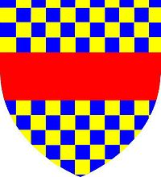

De Lisle Leopard

Interesting points about Adam’s relationship with his father
calls him by his name
Note the conflict between Hugh and Adam.
Why is there conflict?
Notice items about Adam’s immaturity
Always calling Nick
His excitement keeps distracting him
shows off rather easily
His identity is in being Rogers son
This changes by the end of the book
Note how this relationship changes in the next few chapters

Roger’s comments about roads and minstrels kind of sets the stage for the book. It has foreshadowing elements in it. It is what Adams learns as he goes through this story. It is illustrated in his experiences, the people he meets and his own maturing.
Map Activity
Mark lesson number
Mark them at St Albans

