Name: Rebecca Beiler
Grade level and subject: 3 and 4 Art; Albrecht Durer, printing; 2 PART
Time: 2:25-3:00

Art Lesson: Albrecht Durer and Printing
Lesson Plan

Instructional Objectives:
The student will be able to…

- Recall in a turn and tell that Albrecht Durer was a Renaissance artist who created woodcuts which were used for printing.
- Create a printing plate and use it to make a print by following instructions given by the teacher.

Materials Needed
- plants (Preferably choose simple leaves, but this also depends on the age level).
- scrap paper
- pencils
- Styrofoam circles (approx. 5” in diameter)—extra for students who NEED to start over
- Bach Music
- 19 paintbrushes
- 9 palettes or plates for rolling brayers in ink
- ink
- ink brayers
- cardstock (cut to size for printing)
- paper to mount the prints on
- cups
- water
- paper towels
- rag

Part 1—Albrecht Durer History; Drawing Leaves on Styrofoam
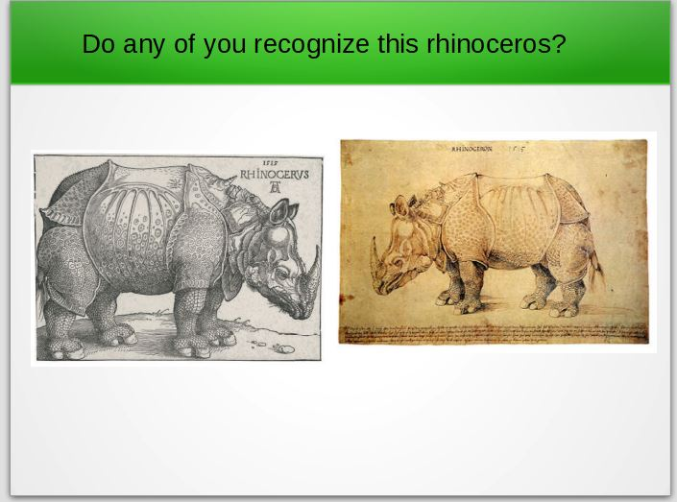
Hook / Anticipatory Set

Slide 1:
Do you recognize this rhinoceros?
We are going to be studying Albrecht Durer.

Teaching / Modeling

- Introduction
Background Information
—Give the students background information about Albrecht Durer.

Slide 2: Albrecht Durer
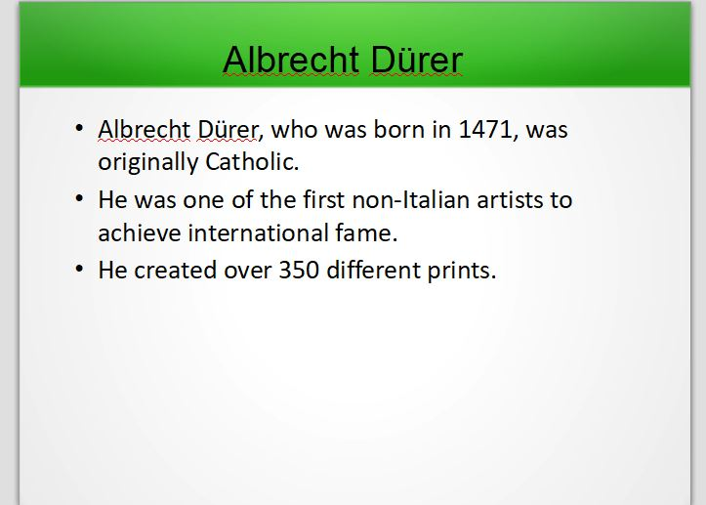
1. Albrecht Dürer, who was born in 1471, was originally Catholic.
—Teach that he was a Renaissance artist. Write Renaissance on the board for visual aide.
2. He was one of the first non-Italian artists to achieve international fame.
3. He created over 350 different prints.
4. This is a self-portrait.

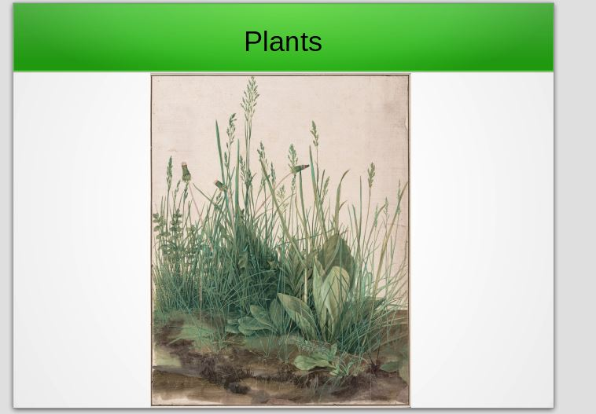
Slide 3: Plants
1. Teach about Albrecht Durer's work with plants. Helpful information is found at: https://www.thecultureconcept.com/albrecht-durer-observing-nature

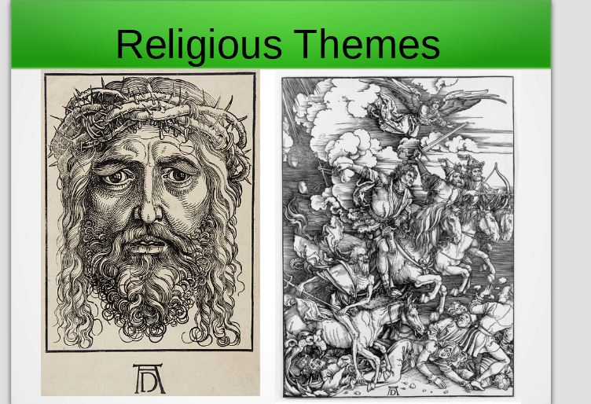
Slide 4: Religious Themes, Woodcuts, and Printing
1. Note religious themes.
—Picture 1: “The Head of Christ Crowned with Thorns”
—Picture 2: “The Four Horsemen of the Apocalypse”
2. Explain how he would carve out the white areas.
Whatever he did not want to print, he would carve out making it lower.
3. Show teacher example of student project.

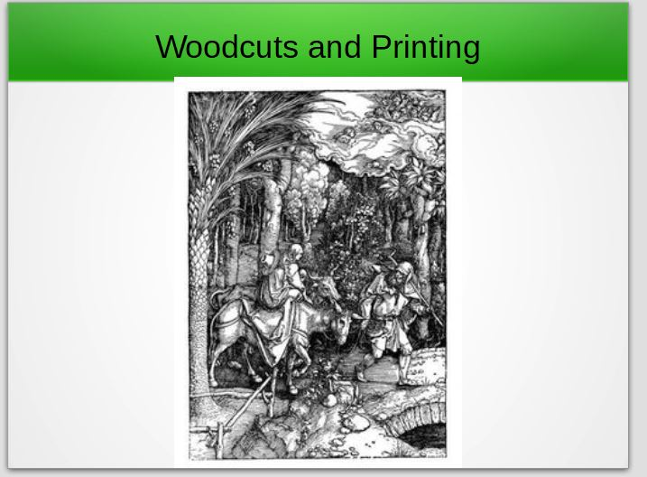

Slide 5: Woodcuts and Printing
1. Notice all the lines in the woodcut.
2. What kind of lines do you notice? Dark, light, short, curved. . .

- Content
Intro to Project
1. Today we are going to make a printing plate like Albrecht Durer did.
2. He made his own plates to print with.
    - Show Styrofoam printing plate.
    - Demonstrate how the printing will work, but do the demonstration without paint. Do this by placing the paper (for the print) on top of the plate while not shifting it on the plate. Use one hand to hold the paper steady on the plate and the other to rub all areas on the plate. This pulls the ink off the plate onto the paper evenly.
3. Directions for the students
    - We will use a pencil to draw the picture we want.
    - This creates dents in the Styrofoam.
    - Show how this printing will be showing only an outline versus Albrecht Durer cut out the negative.
    - The “gullies” or dents are where the Styrofoam will not touch the paper.
    - This makes a print.
      - How else could we do this? Negative cut to make positive print
      - Would it be more difficult?

Plant gathering
1. Either take the students out to the ditch and have them gather a few leaves or have some leaves ready for art class and simply distribute them.
    - Just as Durer used plants sometimes as subject matter for his art, we are going to do the same.

Drawing
Bach music. Compliments to the Renaissance. :)
1. Demonstration
- Have the students gather around a desk and show.
- If there is a large classroom, have the students gather around in groups.
- Show how to draw several generic leaf shapes in the Styrofoam.
2. Practice
- Part 1
  - Have students place the plant on their desk.
  - Trace the shape with your pencil eraser.
    - Think about the shapes and lines you are creating.
    - Use your eraser to “draw” the leaf on your scrap paper.
- Part 2
  - Have the students quickly practice by drawing the plant on a piece of scrap paper.
  - Tell the students that they will not be able to erase when they are drawing the Styrofoam, so they should think about what they are going to be drawing.
    - Maybe have some students trace a leaf for the project. (Preferably not; they should learn to draw). Just remember to keep the leaves simple.
3. Styrofoam—Direct students on drawing on the Styrofoam
  - Think about the lines you are seeing on the leaf.
  - Draw with a pencil.
  - Make sure the pencil is not too sharp.
  - You may want to draw it lightly then trace your lines harder.
  - Press enough that it creates fairly deep indentations.

Turn music off. Signal for students to work quietly.

Conclusion/Wrap-up
    - Thank-you for working hard on your pictures.
    - We made a printing plate today, but we did not get to print.
    - Who wants to tell me something they learned about Albrecht Durer today?
    - Hand out papers for students to write things that they learned about Albrecht Durer.
    - Next time, we will learn some more fun things about him!

Part 2—The Story of “The Praying Hands;” Printmaking
Hook / Anticipatory Set

Slide 5:
1. Do you remember who we learned about the last time?
2. What can you tell me about him?
Quickly review the content about Albrecht Durer.
1. Go through the slides.
2. Pause at Slide—Woodcuts and Printing
- More details about the woodcuts and printing than
the last lesson.

Teaching / Modeling

- Introduction
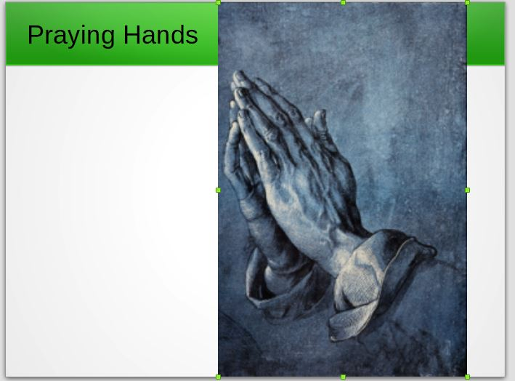
Slide 7:
Tell the Story of “The Praying Hands”
Story can be found at http://barefootsworld.net/albrechtdurer

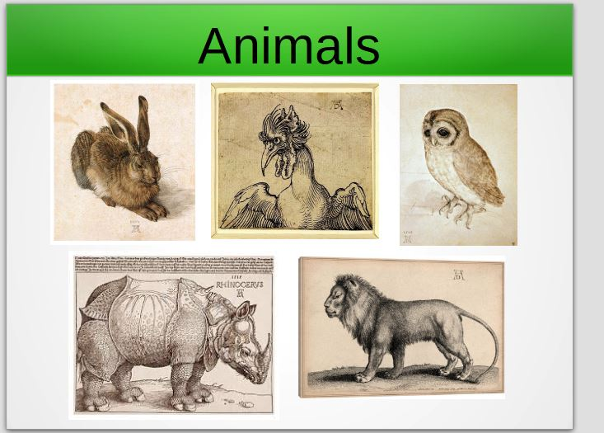
Slide 8: Animals
1. Show students artwork of animals he created.
2. Go back through presentation and note the
initials.
3. If time: have students design their own initials. You could possibly have students create their own unique initials. You could have them put it on their prints when they are finished.

- Content
Intro to Painting
Have you used paints before?
        - They are a lot of fun!
    - They can be a mess!
    - Do you think we can have fun and have a clean mess? :)
How do we handle wet paints?
What do you do with your brush when it has paint on it?
What do you not do with it?

Demonstrate painting
Have the students gather around desk to show them. Again if there is a large class it may work better to do it in groups.
    - Paint the surface of the Styrofoam over the etching of your picture. (your printing plate)
    - Place the paper on top of the printing plate.
    - Make sure it does not slide around. To do this you will hold it in place with one hand while you rub the paper all around with the palm of your hand.

Hand out paints
- One Palette for partner group
- 1 Brayer
- Ink
Closure
- Conclusion
Music off. Signal for students to work quietly to finish.
- Assessment:
  - What is Albrecht Durer known for?
  - From what era was Albrecht Durer?
- Cleanup: Have them clean up in groups. Quietly :)

*Please Note: I did this lesson with tempera paints and paint brushes. It works, but your prints will not be as nice. And you may need to have students do a new print several times to get the results you want. It works well if you are on a budget that does not allow for extra art supplies, but if you want to have better success the ink and brayers are preferable.

Editor’s note: This lesson is fairly complicated for grades 3 & 4. They may need to try a few times before they get a good print. Older grades might do better with this than grades 3 & 4.

