Algebra I Class Work 5.2
Name ______________________
Directions: You may use your book, notes, calculator, friends, and teacher. However you may not copy someone else work verbatim. Show all your work. If you are not finished at the end of class, write “NEED MORE TIME” at the top and turn your paper in – you may not take it home. You have one week to finish it.

- Write set notation for the mapping diagram.

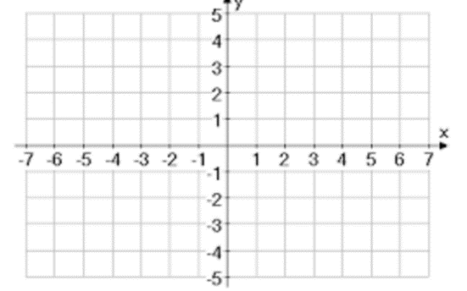
- Draw the graph for the mapping diagram.

- State the domain and range of the relation.
{(-1,3),(-2,5),(0,7),(3,-4),(4,8)}

- Determine if the relations in 1 – 3 are functions.

