Algebra II Class Work 2.1
Name ______________________
Directions: You may use your book, notes, and calculator. You may talk to other people in the class, and you may ask me questions. However you may not copy someone else work verbatim – you should write your answer in your own words. Show your work. If you work until the end of class and you’re not done, write “NEED MORE TIME” at the top and turn your paper in – you may not take it home. You can ask me for it anytime within one week to finish.

- Write set notation for the mapping diagram.

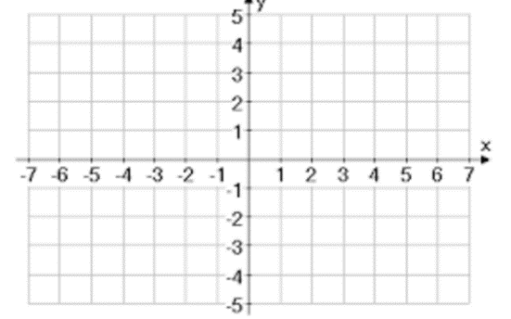
- Draw the graph for the mapping diagram.

- State the domain and range of the relation.
{(-1,3),(-2,5),(0,7),(3,-4),(4,8)}

- Determine if the relations in 1 – 3 are functions.

