Name: ________________________
Date: _________________________
Score:_________________________

Biology Test – Module #10
Matching: Match each term with the correct definition. (2 pts.)
- ____ ecology | - The process by which certain gases (principally water vapor, carbon dioxide, and methane) trap heat that would otherwise escape the earth and radiate into space
- ____ population | - A diagram that shows the biomass of organisms at each trophic level
- ____ community | - A group of ecosystems classified by climate and plant life
- ____ ecosystem | - The study of the interactions between living and nonliving things
- ____ biome | - Evaporation of water from the leaves of a plant
- ____ primary consumer | - A group of populations living and interacting in the same area
- ____ secondary consumer | - An organism that eats primary consumers
- ____ tertiary consumer | - A group of interbreeding organisms that coexist together
- ____ ecological pyramid | - An ecosystem where all water runoff drains into a single body of water
- ____ biomass | - An organism that eats producers
- ____ transpiration | - An organism that eats secondary consumers
- ____ watershed | - An association of living organisms and their physical environment
- ____ greenhouse effect | - A measure of the total dry mass of organisms within a particular region

True or false: Determine whether each statement is true or false.
- ___ For an ecosystem to continue surviving, it must have a constant source of energy.
- ___ The carrying capacity is limited by the available resources.
- ___ An autotroph is not able to make its own food.
- ___ A herbivore is a plant eating animal.
- ___ Each consumer level of the food pyramid utilizes approximately 10% of its ingested nutrients to build new tissue.

List: Complete each list
- List two forms of symbiosis.
  - _________________________________
  - _________________________________

Short answer: Give the best definition/explanation for each term.
- Carrying capacity ________________________________________________________________________________________________________________________________________________________________________________________________________________________
- Steady State ________________________________________________________________________________________________________________________________________________________________________________________________________________________
- Symbiosis ________________________________________________________________________________________________________________________________________________________________________________________________________________________

List each organism and its possible trophic levels on the following food web.
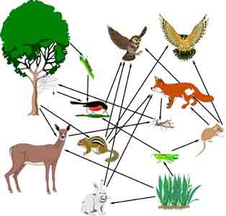

Organism | Possible Trophic Levels

