Name: ____________________
Date: _____________________
Score: ____________________

Biology Test – Module # 14

Matching: Match each term with the correct definition
- ___ Botany | - Nonliving vascular tissue that carries water and dissolved minerals from the roots up to its leaves
- ___ Perennial plants | - A fine dust that contains the sperm of seed-producing plants
- ___ Annual plants | - The characteristics of the leaf edge
- ___ Biennial plants | - The study of plants
- ___Xylem | - Plants that live for only one year
- ___ Phloem | - The parts of a plant (such as stems, roots, and leaves) that are not involved in reproduction
- ___ Leaf margin | - Living vascular tissue that carries sugar and organic substances down the plant
- ___ Deciduous plant | - Plants that grow year after year
- ___ Pollen | - A plant that loses its leaves for winter
- ___ Vegetative organs | - Plants that live for two years

True or false: Determine whether each statement is true or false.
- ___ A person that studies plants is called a botanist.
- ___ Leaves are green because they contain chlorophyll.
- ___ Usually the underside of a leaf is darker green that the top.
- ___ Leaves fall off of trees in the Fall because of an abscission layer.
- ___ Leaves that turn brown have citric acid in them.
- ___ Two functions of roots are absorb water and anchor the plant.
- ___ A dicot is able to produce new xylem and phloem.
- ___ Moss is composed of one big plant.
- ___ Mosses reproduce by a method called alternation of generations.
- ___ A small fern is called a fiddlehead.

List/fill in the blank
- List the two types of roots.
  - ________________________________
  - ________________________________
- List a function of stems
  - ________________________________

- What kind of root system does a carrot have? _____________________________
- What type of venation does this leaf have? ________________________________
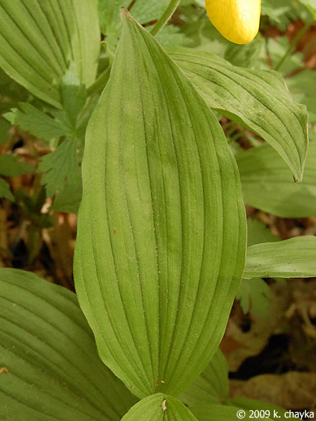
- You see a plant that is five feet tall. Can it by a Bryophyte? _____________

Label: Labe the following diagrams.
