Name: ____________________
Date: _____________________
Score: ____________________
Biology Test – Module #15
Matching: Match each term with the correct definition.
- ____ physiology | - A growth response to gravity
- ____ pore spaces | - A mature ovary that contains a seed or seeds
- ____ cohesion | - The study of life processes in an organism
- ____ loam | - A growth response to touch
- ____ hormones | - An ovule with a protective coating, encasing a mature plant embryo and a nutrient source
- ____ phototropism | - Spaces in soil that determine how much water and air the soil can hold
- ____ gravitropism | - Flowers with both stamens and carpels
- ____ thigmotropism | - The phenomenon that occurs when individual molecules are so strongly attracted to each other that they tend to stay together, even when exposed to tension
- ____ perfect flower | - The transfer of pollen grains from the anther to the carpel in flowering plants
- ____ imperfect flower | - A growth response to light.
- ____ pollination | - Flowers with either stamens or carpels, but not both
- ____ seed | - Chemicals that circulate throughout multicellular organisms, regulating cellular processes by interacting with specifically targeted cells
- ____ fruit | - A mixture of gravel, sand, silt, clay, and organic matter

Label: label the parts of the flower
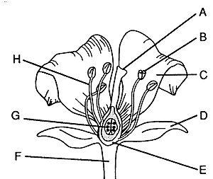
- What do all plants need? ______________________
- List at least two plant hormones.
  - _______________________________
  - _______________________________
- Give one example of vegetative reproduction and how it happens. ________________________________________________________________________________________________________________________________________________________________________________________________________________________

Classification of fruits: Recreate the classification chart of fruits.

True or false: Determine whether each statement is true or false.
- ___ Grafting is a form of vegetative reproduction.
- ___ Bees help pollinate certain flowers.
- ___ A cherry branch can be grafted onto an apple tree.
- ___ Soil needs some air spaces in it so that it can absorb water well.
- ___ Turgor pressure helps a plant remain stiff and upright.

