7: Finding Canada Activity

Purpose: Create a map of the early explorers of Canada.

- Resources needed:
  - Pencil Crayons
  - Map of modern Canada
- You will plot the routes of several explorers on the map of Canada on pg 3 using the directions given below.
  - Each voyage should be assigned a different colour. Include arrows along your lines to indicate direction of travel.
  - Label lands, settlements, and bodies of water listed in bold on the map. Use arrows to place labels where space is tight.
  - Remember to include a key and compass (a good space is in the province of Quebec).
- Additional notes:
  - You might benefit from first marking a route with pencil before colouring.
  - Only 2 resources are off limits- your course binder and any map(s) that are of the type you are creating.
  - Make sure you can distinguish between Newfoundland (the island) and Labrador (the part on the mainland- north of Newfoundland, east of Quebec). Also identify Greenland and the Atlantic Ocean on your map.
  - If you wish, be creative and include comments, drawings, humour, etc.

Grading
- 10 points possible for each of the following:
  - _______ Viking voyage
  - _______ Cabot’s 1st voyage
  - _______ Cartier’s 1st voyage
  - _______ Cartier’s 2nd voyage
  - _______ Cartier’s 3rd voyage
  - _______ Hudson’s voyage
  - _______ Map key
  - _______ Location labels
  - _______ Overall neatness
  - _______ Evident effort
Works Referenced

Instructions

- Leif Ericsson (1001)
  - From Greenland. Settlement at L’Anse aux Meadows- label its location on northern peninsula of the island of Newfoundland. Likely continued further south (don’t enter Gulf of St. Lawrence).
(Do not draw a return.)

- John Cabot (1497, 1498)
  - From England. Landed at the southern side of Newfoundland and claimed it for England. Then discovered the Grand Banks and returned to England.
  - We do not know where he went on his second voyage, on which he disappeared. (You do not need to draw this voyage at all.)

- Jacques Cartier (1534, 1535, 1541)
  - From France. Discovered and went through the Strait of Belle Isle (between Newfoundland and Labrador).
Headed south along the coast of Newfoundland, exploring the Gulf of St. Lawrence.
Traded with natives along the coasts of Prince Edward Island and then New Brunswick’s Chaleur Bay (located between NB and Quebec).
Met Donnacona and the Iroquois along Quebec’s Gaspe Peninsula then continued around the east of Anticosti Island and up along the north side of the Gulf, back through the Strait of Belle Isle and home.

  - From France, through the Strait of Belle Isle. Southwest along the Labrador/ Quebec coast, staying north of Anticosti Island and into the St. Lawrence River.
Found Stadacona (at the site of modern Quebec City) and went on to Hochelaga where he named Mont Real. Back to Stadacona where they stayed over winter.
Left the St. Lawrence, this time staying south of both Anticosti Island and Newfoundland, probably stopping briefly at the southeast corner or Newfoundland before returning home.

  - Came with Roberval to establish a colony near Stadacona. Route was similar to the second voyage. Returned to France after the attempt at settlement failed.

- Henry Hudson (1610)
  - From England, via Greenland. At the northmost point of Labrador, started following the coast of northern Quebec. Ungava Bay, Hudson Strait, then south into the Hudson Bay staying along Quebec’s west coast. Down into the James Bay. Somewhere here Hudson’s men rebelled and expelled him from the ship before heading back to England themselves. (Don’t draw this return, you can stop in the James Bay.)
map
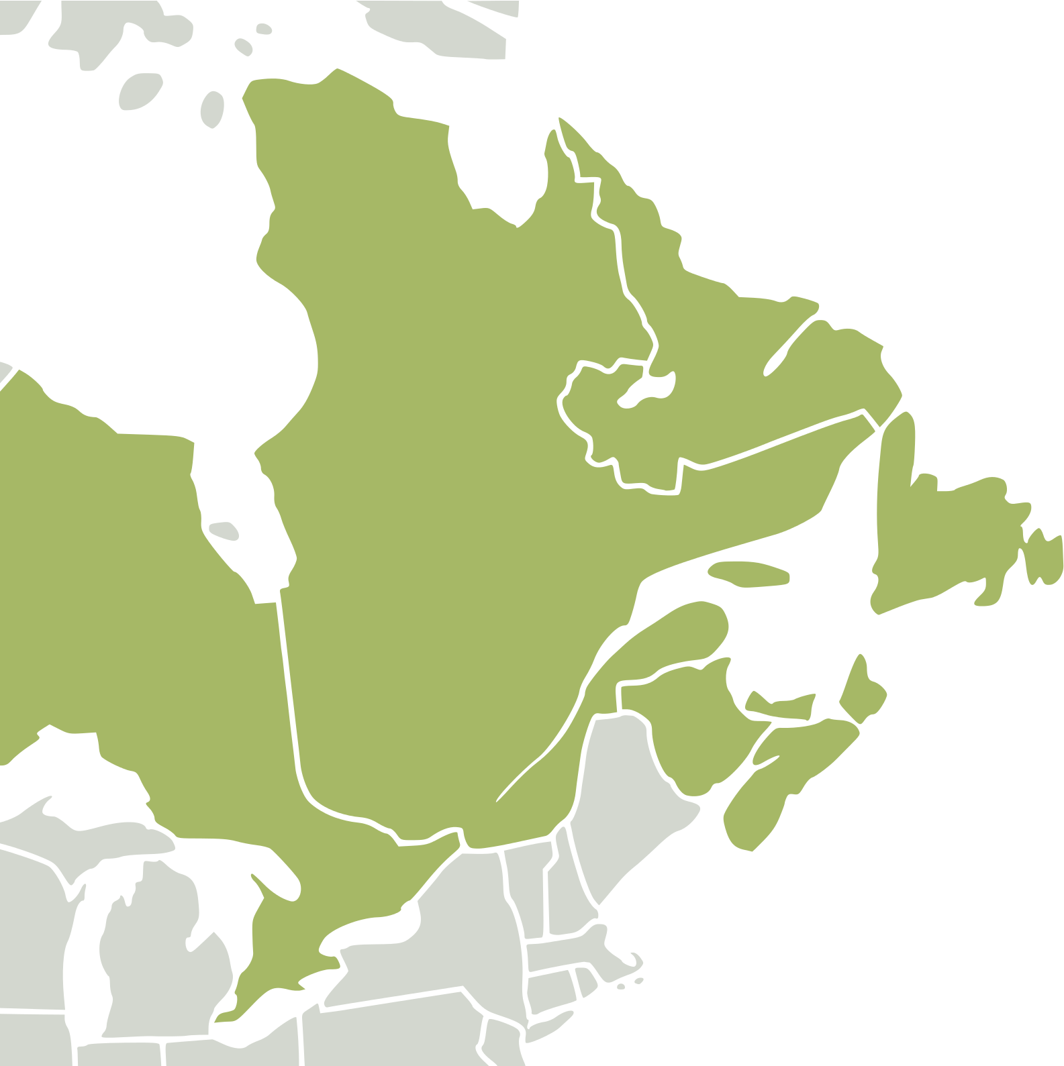
(blank)

The Kids Book of Canadian Exploration by Ann-Maureen Owens and Jane Yealland (2004. Kids Can Press: Toronto) and Atlas of Canada by the Royal Canadian Geographical Society (2014. Collins: Toronto)
https://www.nicepng.com/ourpic/u2r5a9e6r5u2r5t4_nearctic-eastern-canada-svg-eastern-canada-map-blank/

