“I take responsibility for myself and for my actions.”
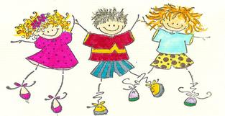
1. Respect myself and others
- Encourage rather than tease
- Walk indoors
- Raise my hand for permission to speak
- Do my best work
2. Use appropriate words to solve problems
- Before telling the teacher, I take responsibility for my problems.
- I ask myself, “How is this my problem?” If it is not my problem, I don’t worry about it. I ignore it.
- Compromise (“Let’s take turns.” “Shall we trade?” “Let’s share.”)
- I ask them to please stop what is bothering me.
- If I am still having a problem with someone, I talk with a teacher.
3. Obey all teachers
- Cheerfully
- Promptly
- Without excuses

Consequences Rewards
Any of the following: Any of the following:
-reprimand -praise
-time-out at recess -encouragement
-go to my seat for time-out -extra recess
-have a privilege taken away -note from tchr. to parent
-extra work -homework passes
-talk to the principal -small prizes
-note from tchr. to parent

As your teacher, I commit myself to respecting you, loving you, and helping you solve problems. I will listen to you and encourage you. I will work with your parents to help you learn and grow. Signed:________________________

A note to the guardian: Please help me to keep you informed by attending conferences, by visiting the classroom, and by sending notes or calling if you have questions and concerns. Please go over this with your child and return it signed. I will then make a copy for you to keep at home. Thank you so much for your support!

Child’s signature:___________________________________________

Guardian’s Signature:________________________________________

