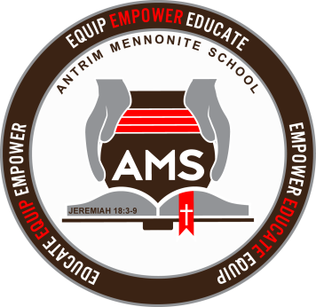
Antrim Mennonite School

AMS Patrons,
Thank you for your flexibility and understanding as we move into this phase of adjusting to the threat of COVID – 19 and follow the state’s guidelines for schools. Continue to pray for the leaders of OH and the US as they continue to make decisions on behalf of the people. Also keep us as a staff in your prayers as we navigate unchartered territory.
In order to avoid social distancing and non-congregating behaviors, we are asking that no social gatherings take place at school during school closure. As staff, we are concerned that as little learning loss takes place as possible; and we will do our best to make sure you as parents have all the help you need to ensure that meaningful learning takes place. During this time, all teachers will be available during normal school hours to answer your questions or any questions students may have concerning their work. It is vital that each family takes responsibility that all the work assigned gets completed in a timely manner. I would also encourage you to set up a schedule that fits your family to do school work and be intentional in creating a learning atmosphere with little distractions. If there are particular concepts that students cannot grasp with your help or by contacting the teacher, we are open to teachers coming and assisting at your home if you feel it’s necessary.
Each teacher will be emailing assignments for their particular grades. We plan to send emails today that include assignments for W, Th, & F. After today, you can expect an email on Friday that includes assignments for M, T, & W and an email on Wed. that includes assignments for Th. & F. There will be files inside the double glass doors of the church entrance for each family with a folder for each student. We ask that all completed work be brought Friday after completion of Thurs. – Fri. assignments (Wed. assignment for this week) and on Wednesday after the completion of Mon. – Wed. assignments. Put the completed work in the manila folder with the student’s name. There will also be a manila folder for each student with the appropriate quizzes and tests needed for the next assignments. If there is nothing in that folder, that signifies there is nothing the student needs for the next assignments. Teachers may also use this folder for communication with you and the student for returning papers or corrections that need done. Take the folder with you and return it the next time you drop off completed assignments. If possible, have completed work here by 3:00 on Friday and Wednesday.
When administering quizzes and tests, please do not show them to the student before taking and remember your integrity in the process of quiz and test taking is crucial for us to know what the students are learning. All quizzes and tests are administered as closed book, and students may not use their books to complete them.
Thanks to ABeka, they have offered all their class videos for our use during this time. We are requiring some grades watch the videos for some of their classes. To access the videos go to abeka.com, log in and enter the username and password. Click on the arrow and then click on hello in the top menu bar. Click on student video lessons and find the appropriate subject and lesson. Each teacher will be letting you know what subjects will be taught via video and which lesson to begin on. All usernames and passwords will be text to you later today. I know this is a different way of learning but I think students will find this enjoyable and may benefit from listening to another teacher for a bit. Again if there any questions or problems with accessing the videos, feel free to contact me.
At this point, we are planning to have Parent-teacher conferences that are scheduled for Monday, March 23. I will be sending schedules for those conferences later this week.
Lastly, these are unchartered waters and we welcome your forbearance and feedback as we figure out what works and what doesn’t. Although this is a difficult time for all of us, there is a silver lining. Remain positive as you interact with your child’s school work and take this opportunity to share valuable family time together with suddenly many cleared schedules. With the flexibility this offers, take it as a time to make memories as a family. This is one of those times that people will look back on and discuss where they were when the Coronavirus closures happened, how they coped, and the unique opportunities we as followers of Jesus had to respond. Though we will all miss school, it has the possibility of being a really unique and even positive childhood memory.
God’s blessing to you all,
Mr. Lapp

