Name: ________________ May 22 - 26, 2017
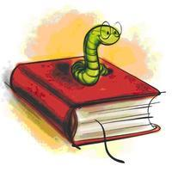
Teacher: Ms. Katrina
Behavior Plan
Blue=Good Day!
Green=Warning
Yellow=Loss of some recess or center time
Red=Loss of privilege, note home, or visit to director’s office

Our School Rules are:
- Respect myself and others.
- Obey teachers.
- Use appropriate words to solve problems.

“Read! Read! Read!”
Behavior | Homework | Comments | Parent Initials
Monday | Grade K: Read orally We Explore: p. 48, “The Big, Big Box.”  Grade 1: | Music
Tuesday | Grade K: Practice Word List 105-9  Grade 1: | Library Class/Show & Tell
Wednesday | Grade K:  Grade 1:  Practice Bible memory. | Extra Centers
Thursday | Grade K:  Grade 1:  Bible Recitation Due  Grade K: “ABC Scriptures”  Grade 1: James 5:7 - 20 | Music
Friday | Grade K:  Grade 1: | “End-of-Year” Event  8:30-8:45 Students to classrooms  9:00 Program in auditorium  12:15 Dismissal

