Doodling Spring Flowers
  - Art Lesson
Anita Yoder
Grades 3 & 4
40 minutes

Lesson goal: Students will follow instructions to complete a selection of patterns within circles, and use their creativity to complete an empty circle and leaves.

Materials: (Have one of each on each desk.)
- Colored paper
- Scrap paper
- Styrofoam cup
- Black Sharpie

Orientation and goals:
- Show several doodling projects (your own or some you find online).
- Tell students they will learn how to make patterns like these today, and can learn to create their own designs.

Lesson
- Instruct students to place the colored paper on top of the scrap paper and keep it that way for the rest of the lesson. This protects the desk from markers bleeding through the paper.
- Ask students to take the cup and trace 5 circles on the top half of their page.
- Show your demo page, to demonstrate that they will want to leave space to add the stems later. Demo:
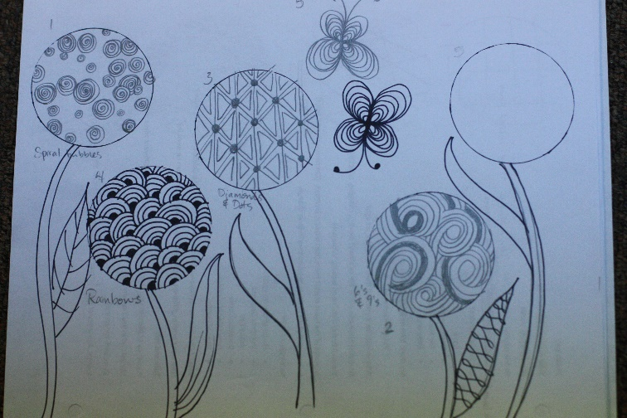
- They can choose portrait or landscape aspect, and whether to use the top or bottom of the cup.
- Encourage variety: some of each size circle.
- Remove cups from desks.
Hang your example sheet on the board.
Draw a big circle on the board to illustrate the following steps: (draw as you explain)

Pattern 1: Draw spiral bubbles
- Choose any of the 5 empty circles.
- Draw circles of many sizes inside the big circle.
- Some can be half circles on the edge of the big circle.
- Inside each circle, draw a spiral. Students can experiment making the spiral lines closer or farther apart.

Pattern 2: Draw 6’s and 9’s (erase your first big circle with spiral bubbles and draw another big circle to draw in as you explain)
- In another area of the board, show the difference between a 6 and 9 with straight stems, and ones with curved stems. Emphasize that these 6’s and 9’s will smooth, swoopy, and loopy, with no straight lines.
- Choose any of the empty circles.
- Draw 3-4 6’s or 9’s coming out of the edge of the circle.
- Choose one 6 or 9, and echo its line, making it fatter and fatter.
- When it’s as fat as you want it, go to the next 6 or 9, and echo its lines.
- Introduce the main rule of this kind of doodling: When you meet a line, STOP.
- When a 6 or 9 is fat enough that it bumps into another line, stop. Don’t cross a line that you’ve already made.
- You can plant a 6 or 9 coming from any part of a fat 6 or 9 and start echoing it.
- Echo all of them until the whole circle is filled in.
- Randomly choose tracks to fill in to add texture.

Pattern 3: Draw diamonds and dots
- Choose an empty circle and draw a grid with 3-4 horizontal and vertical lines.
- Turn the paper so that grid becomes diamonds set on edge.
- Draw a line that goes through each point where diamonds meet. This cuts each square in half.
- Draw little triangles inside each big triangle.
- Draw a dot at each intersecting point.
Step-out drawing:
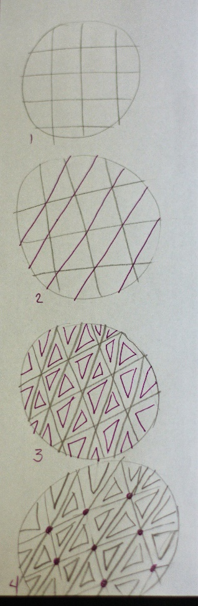
Pattern 4: Draw rainbows
- Choose an empty circle and draw a small half circle on the edge.
- Color in the half circle.
- Echo the half circle 3-5 times, to resemble a rainbow.
- Draw a small cone shape from the edge of the circle to the edge of the first rainbow.
- Color in the cone, and echo it.
- Keep building rainbows until the circle is completely filled.
- Remember: when you meet a line you’ve already made, don’t cross it.

Pattern 5: Draw butterflies
- Anywhere outside a circle, draw 4 little teardrops in an X shape, with every point meeting exactly in the center.
- Echo each teardrop, beginning and ending each loop at exactly the same spot.
- Make fewer echoes on the top or bottom two, to make them smaller wings.
- Draw 2 swooping lines out of the center top or bottom, with dots on the end, for antennae.
Pattern 6: Create your own pattern or repeat any pattern in the 5th empty circle.
Draw stems from each flower circle to the bottom of the page. Keep the lines curving smoothly, with no corners. If a stem meets another flower on the way down, stop the line and continue on the other side.
Draw leaves anywhere on the stems, creating your own ideas of patterns.
Sign your name on the lower right corner like an artist does, and hang on the wall!
