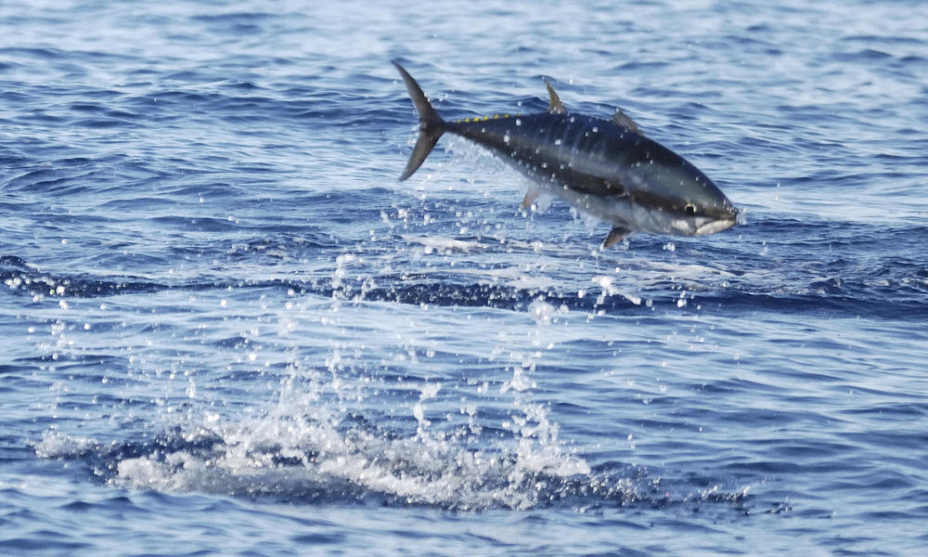

This giant fish is prized for its meat. However, severe overfishing and illegal fishing may cause it’s extinction in the next 25 years if nothing is done to help.

*Thunnus thynnus*

# Atlantic Bluefin Tuna

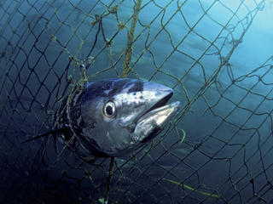

* Size: 1500 – 2000 lbs.
* Length: 6 – 10 ft.
* Habitat: Atlantic Ocean
* Status: Endangered

A million dollar fish!

These fish are highly prized. A single fish was sold for 1.75 million dollars.

Why do They Matter?

These giant predators are at the top of the marine food chain, and serve a vital role in maintaining ecological balance.

What is Being Done?

The WWF has been tagging and collecting data about the Bluefin tuna for over 10 yrs. This allows them to inform fisheries about how they can help manage these fish.

# How Can You Help?

