Names___________________________________________

What is the center of the hurricane called? ______________________

What are two things you will see in a hurricane?
1. _________________________________________
2. _________________________________________

What kind of damage might a hurricane do?
____________________________________________________
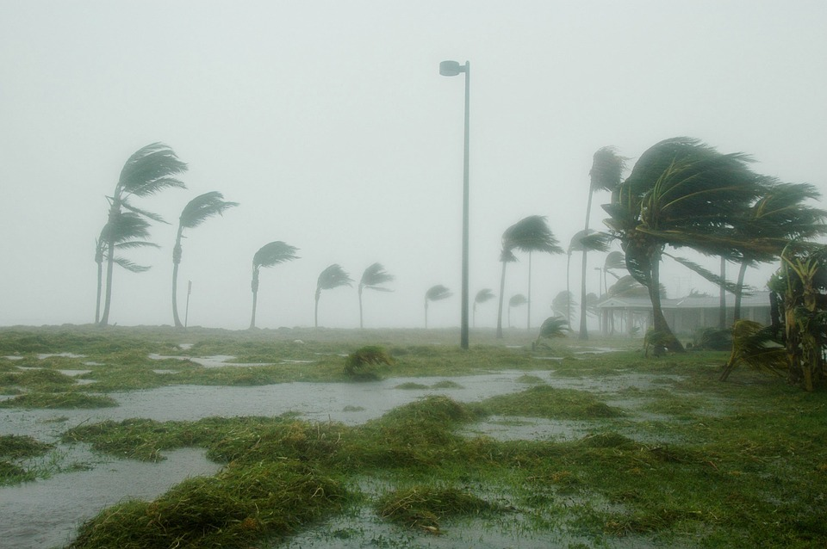
Names ___________________________________________

What are two things that it takes to make a blizzard?
1. _________________________________________
2. _________________________________________

Why is a blizzard dangerous?
__________________________________________________________
__________________________________________________________

What can you do to stay safe in a blizzard?
__________________________________________________________
