http://commons.wikimedia.org/wiki/File:U.S._party_affiliation.svg#mediaviewer/File:U.S._party_affiliation.svg

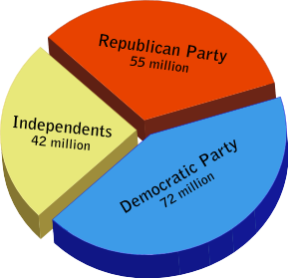

Major political parties

Political Party | States* | Founded in | Former Titles | International Affiliations
Democratic Party | 50 + DC | 1828 |  | Progressive Alliance^{[2]}
Republican Party | 50 + DC | 1854 |  | International Democrat Union
Libertarian Party | 45 + DC^{[3]} | 1971 |  | Interlibertarians^{[4]}
Green Party | 37 + DC^{[5]} | 1991 |  | Global Greens
Constitution Party | 37^{[5]} | 1992 | U.S. Taxpayers' Party | None

Minor political parties
This listing of minor parties does not include independents.
Political Party | Founded in | Former Titles | International Affiliations
America First Party | 2002
American Conservative Party | 2008
American Freedom Party | 2010 | American Third Position Party
American Populist Party | 2009
America's Party | 2008 | America's Independent Party
Christian Liberty Party* | 1996 | American Heritage Party
Citizens Party of the United States | 2004 | New American Independent Party
Communist Party USA | 1919 |  | International Meeting of Communist and Workers' Parties
Freedom Socialist Party | 1966
Independent American Party | 1998
Justice Party | 2011
Modern Whig Party | 2008
National Socialist Movement | 1974 | National Socialist American Workers Freedom Movement | World Union of National Socialists
Objectivist Party | 2008
Party for Socialism and Liberation | 2004
Peace and Freedom Party | 1967
Pirate Party | 2006 |  | Pirate Party International (observer)
Prohibition Party | 1869
Reform Party of the United States of America | 1995 | United We Stand America
Socialist Action | 1983 |  | Fourth International
Socialist Alternative | 1986 | Labor Militant | Committee for a Workers' International
Socialist Equality Party | 1966 | Workers League | International Committee of the Fourth International
Socialist Party USA | 1973
Socialist Workers Party | 1938 |  | Pathfinder tendency (unofficial)
United States Marijuana Party | 2002
United States Pacifist Party | 1983
Unity Party of America | 2004
Workers World Party | 1959
http://en.wikipedia.org/wiki/List_of_political_parties_in_the_United_States

