http://www.daveramsey.com/article/how-teens-can-become-millionaires/lifeandmoney_kidsandmoney/

Ben and Arthur were friends who grew up together. They both knew that they needed to start thinking about the future. At age 19, Ben decided to invest $2,000 every year for eight years. He picked investment funds that averaged a 12% interest rate. Then, at age 26, Ben stopped putting money into his investments. So he put a total of $16,000 into his investment funds.
Now Arthur didn’t start investing until age 27. Just like Ben, he put $2,000 into his investment funds every year until he turned 65. He got the same 12% interest rate as Ben, but he invested 31 more years than Ben did. So Arthur invested a total of $78,000 over 39 years.
HAVE STUDENTS COME UP WITH AMOUNTS THEY INVESTED
When both Ben and Arthur turned 65, they decided to compare their investment accounts. Who do you think had more? Ben, with his total of $16,000 invested over eight years, or Arthur, who invested $78,000 over 39 years?
Who was ahead?
-how much?

-$16,000 can become almost $2.3 million
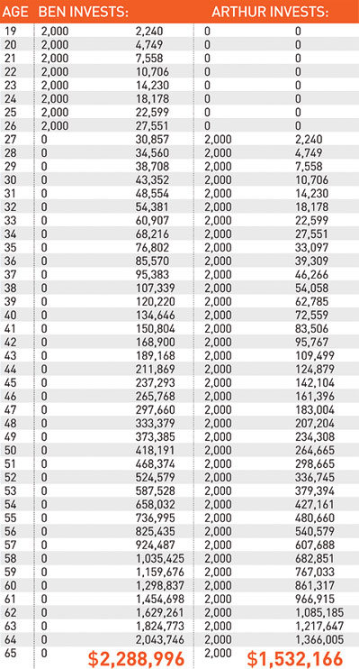
Believe it or not, Ben came out ahead … $700,000 ahead! Arthur had a total of $1,532,166, while Ben had a total of $2,288,996. How did he do it? Starting early is the key. He put in less money but started eight years earlier. That’s compound interest for you! It turns $16,000 into almost $2.3 million! Since Ben invested earlier, the interest kicked in sooner.

