Money
-paper money is printed by the federal government
-debit card: card that deducts purchases from your bank account
-allows you to spend money you have
-credit card: card that authorizes purchases on credit
-allows you to spend money you don’t have
-how do credit cards make money?
-charge the merchants
-charge late fees:
-charge interest on any balance not paid in full every month
-DISCUSS advantages/disadvantages

Saving money
-Why?

-FDIC insures bank deposit up to $250,000

Interest
-simple: on principal
-compound: on principal and interest

EXAMPLE dif in simple and compound interest
$1000 4% for 30 years
-simple: I=PRT
-compound: A_{t}=A_{o}(1+r)^{t}

LOOK at Ben vs. Arthur overhead
http://www.daveramsey.com/article/how-teens-can-become-millionaires/lifeandmoney_kidsandmoney/

Ben and Arthur were friends who grew up together. They both knew that they needed to start thinking about the future. At age 19, Ben decided to invest $2,000 every year for eight years. He picked investment funds that averaged a 12% interest rate. Then, at age 26, Ben stopped putting money into his investments.
Now Arthur didn’t start investing until age 27. Just like Ben, he put $2,000 into his investment funds every year until he turned 65. He got the same 12% interest rate as Ben, but he invested 31 more years than Ben did.
Amount Ben saved: _________
Amount Auther saved: _________
When both Ben and Arthur turned 65, they decided to compare their investment accounts. Who do you think had more? Ben, with his total of ------- invested over eight years, or Arthur, who invested ---------- over 39 years?

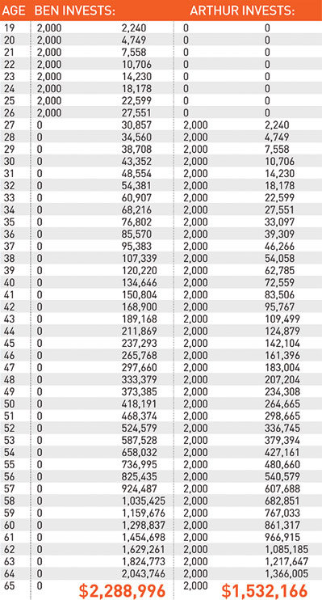
Believe it or not, Ben came out ahead … ____________ ahead! Arthur had a total of $1,532,166, while Ben had a total of $2,288,996. How did he do it? Starting early is the key. He put in less money but started eight years earlier. That’s compound interest for you! It turns __________ into almost $2.3 million! Since Ben invested earlier, the interest kicked in sooner.

