Science Test
Unit 3
Weather

Name ____________________________ Date _____________
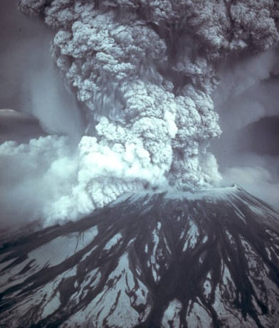
Match the storm to the correct picture.

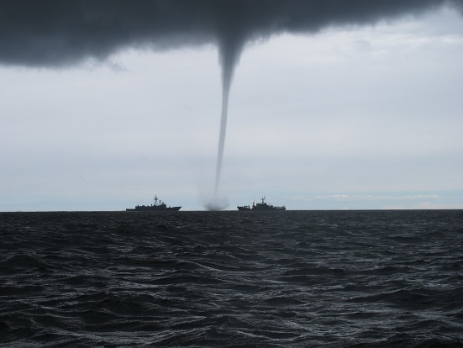
Thunderstorm
Volcano
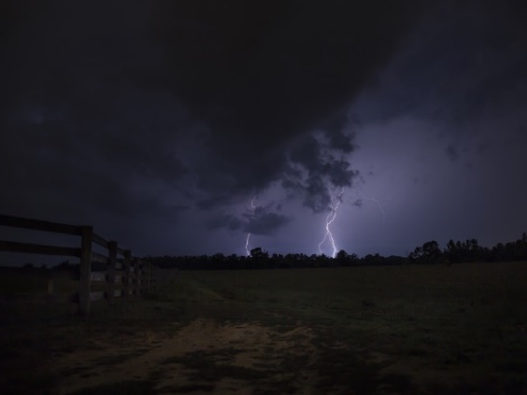
Tornado
Hurricane
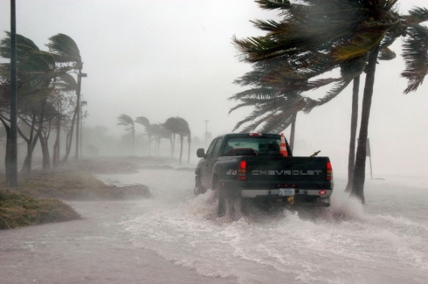

Write a sentence telling something about each of these kinds of storms.
Blizzard
____________________________________________________________________________________________
Earthquake
____________________________________________________________________________________________
Answer the questions.
Who controls the weather? _______________
Who can take care of us? _________________
What are some things that make different weather?
________________________________________________________________________________________________________
Draw the water cycle.

