Music Rudiments Name_____________________________________
Worksheet 1.1
Letters of Lines and Spaces

Letters of the Treble Clef Staff

The letters for the spaces of the treble clef spell “FACE” from the bottom up.
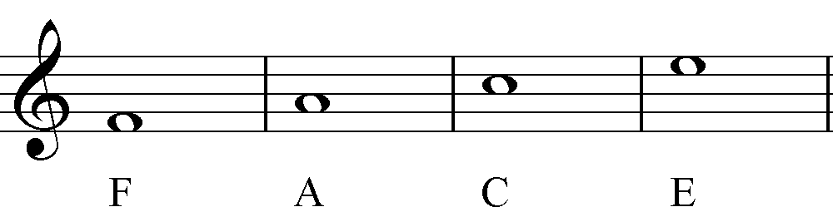

A good acronym to help remember the lines is “Every Good Boy Does Fine.”
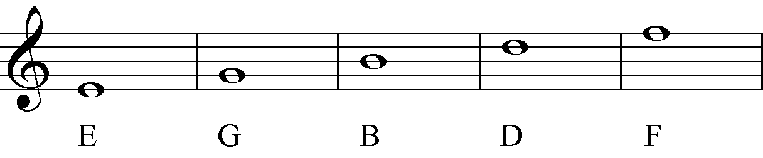

The three notes above the treble clef staff spell “GAB.”
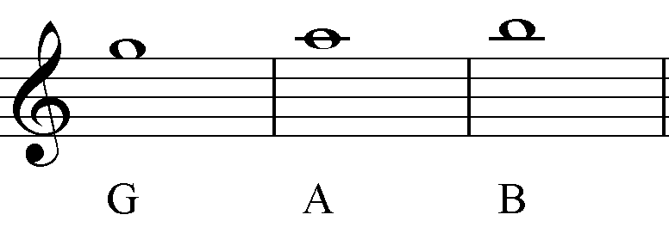

The first ledger line under the treble clef staff is middle C. Therefore, the three notes under the staff are “BCD” as shown below.
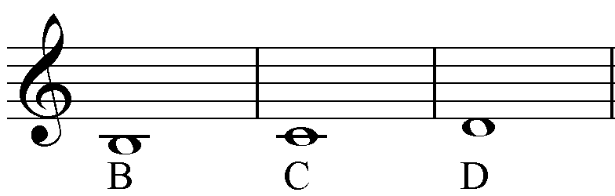

- Place the correct letter name under each note given on these treble clef staves.
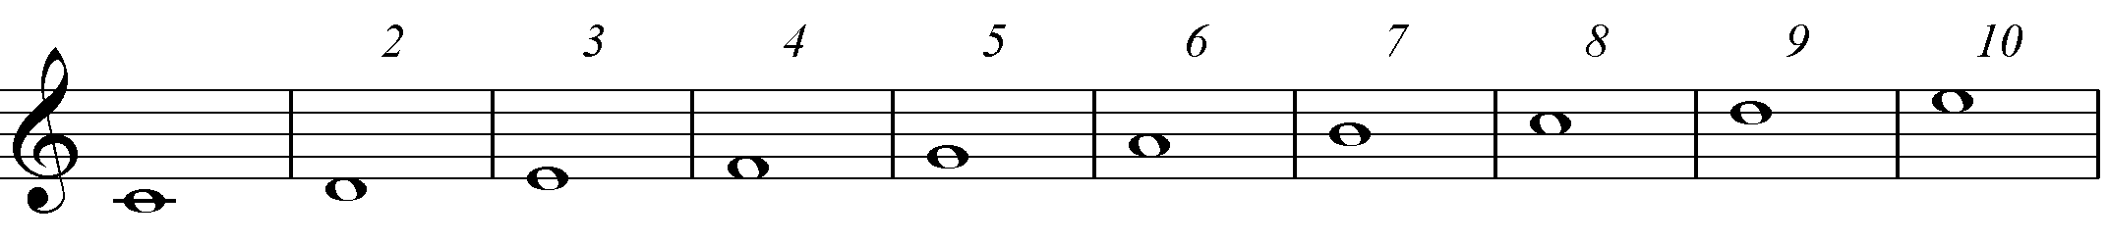

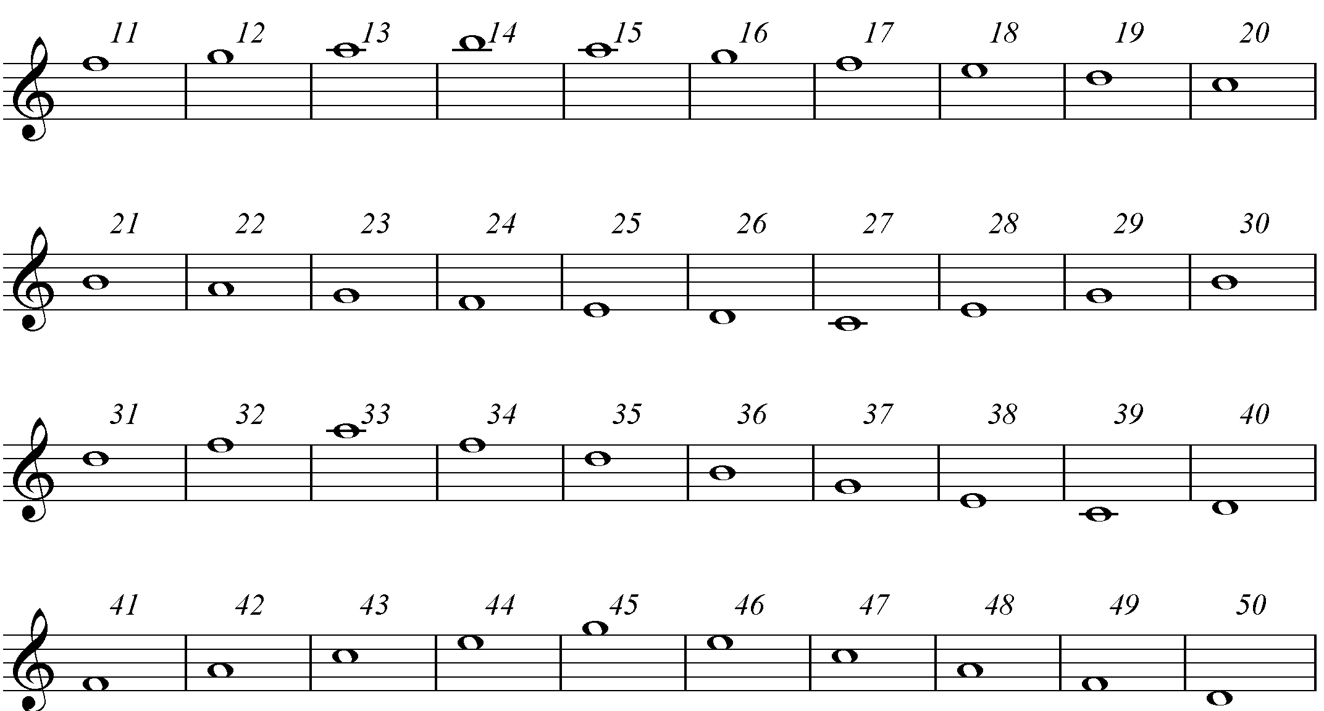

Letters of the Bass Clef Staff

A good acronym to help remember the lines is “All Cows Eat Grass.”
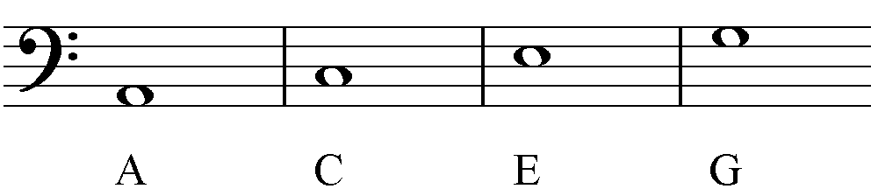

A good acronym to help remember the lines is “Great Big Dogs Fight Animals.”
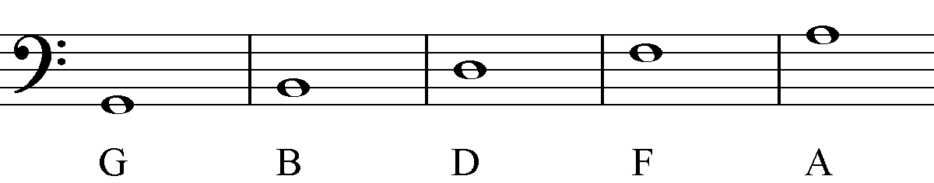

The first ledger line above the bass clef staff is middle C. Therefore, the three notes above the staff are “BCD” as shown below.
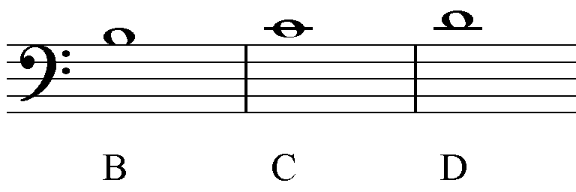

The three notes under the bass clef staff spell “FED” going down.
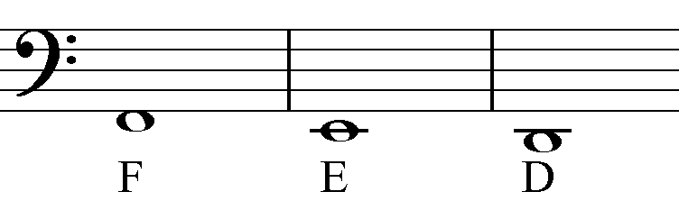

- Place the correct letter name under each note given on these bass clef staves.

