Music Rudiments Name_________________________
Worksheet 1.3

- On the blank line, rewrite the following row of notes using beams. Make beam groups which are equal to quarter notes.
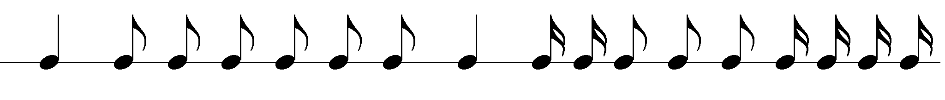

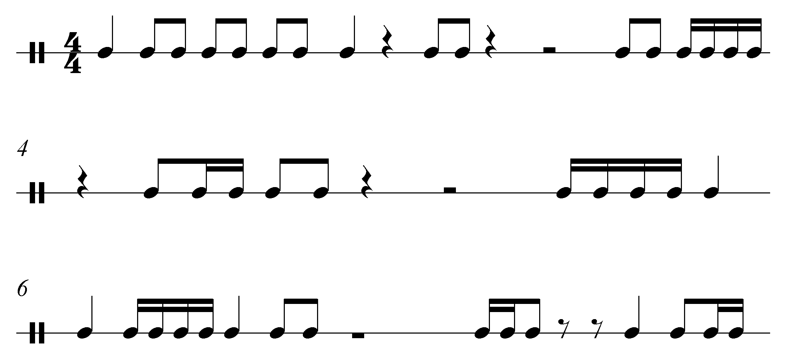
- Place bar lines.

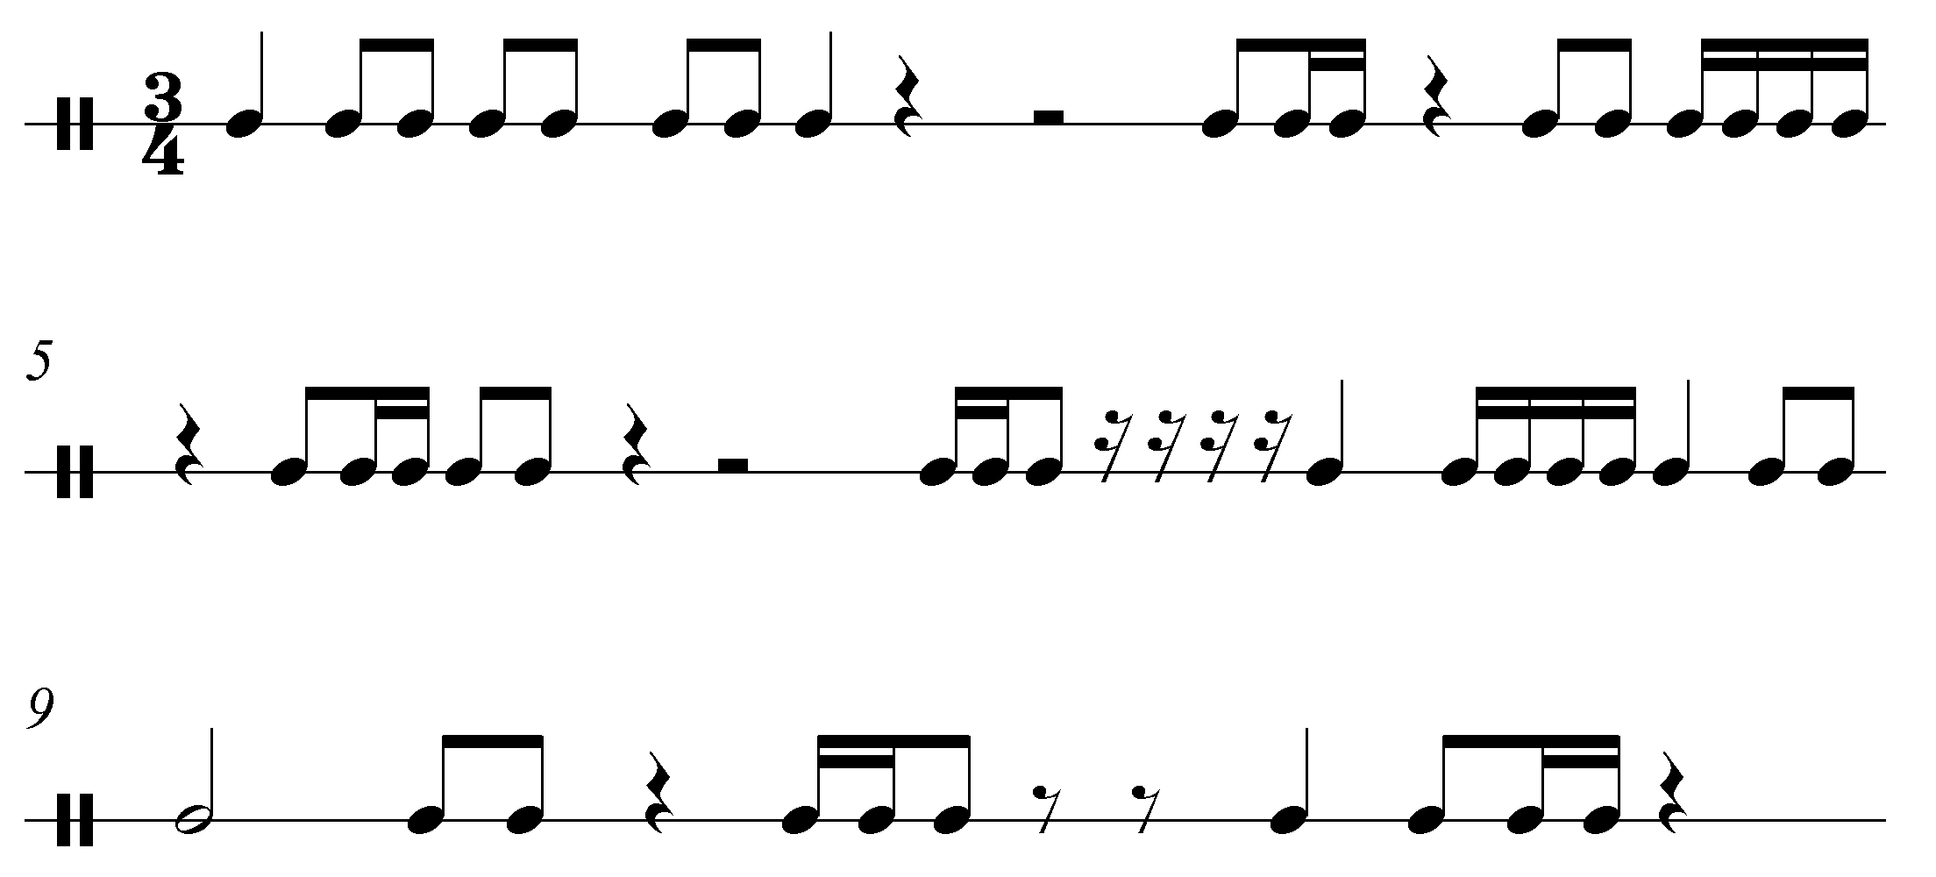
- Place bar lines. Notice the new time signature.

- Identify each note with the correct letter name.

