Music Rudiments Name________________________
Worksheet 1.5

- Complete the following with the correct number
a.

b.

c.

d.

e.

f.

g.

h.

- Write the correct count under each note and rest. For rests, place count in parenthesis.

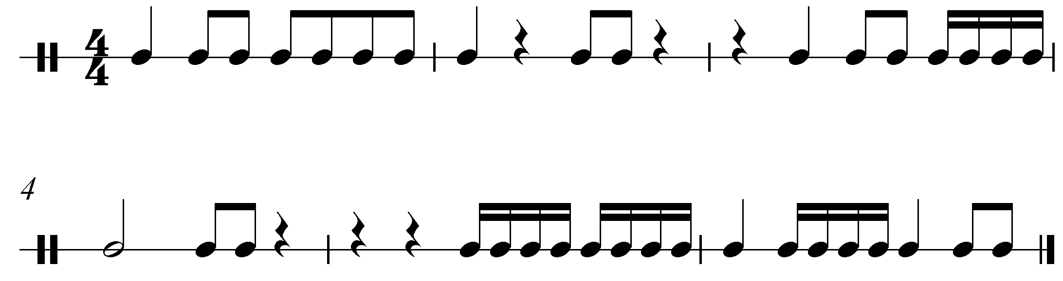

- Fill in the blank.
  - A _______ is a curved line joining two notes of the same pitch.
  - A _______ is a curved line joining two notes of different pitches.
  - A ___________ __________ is a curved line that indicates a complete musical thought.

- Place an "S" above each slur. Place a T above each tie. Place a PM above each phrase mark.

