Music Rudiments Name_________________________
Worksheet 1.7

- Write count under each note and rest. Place counts under rests in parenthesis.
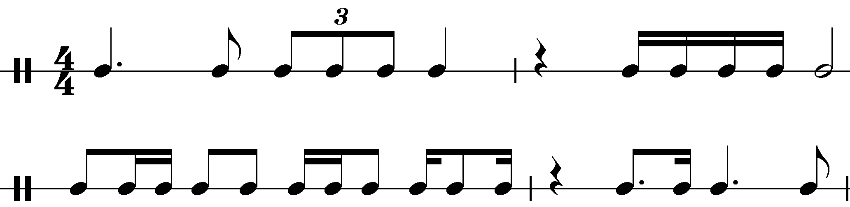

- Write count under each note and rest in these lines using a
time signature. Place time counts under rests in parenthesis.
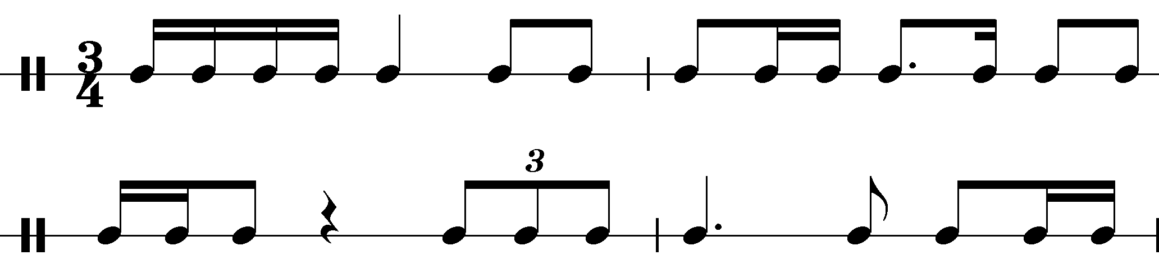

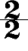
- Write count under each note and rest in these lines using a
time signature. Place counts under rests in parenthesis.
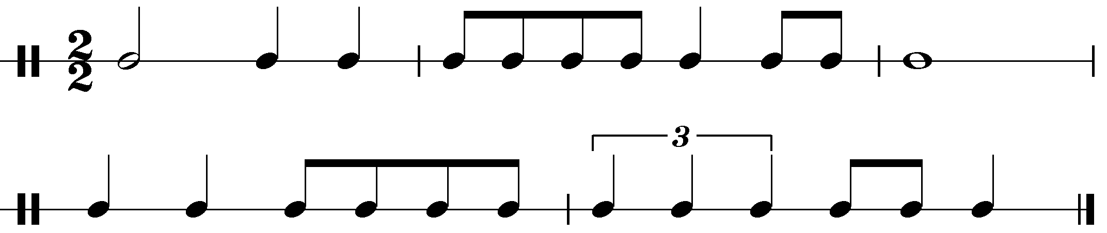

Conducting Patterns

