Music Rudiments Name___________________
Worksheet 1.8
Enharmonic notes

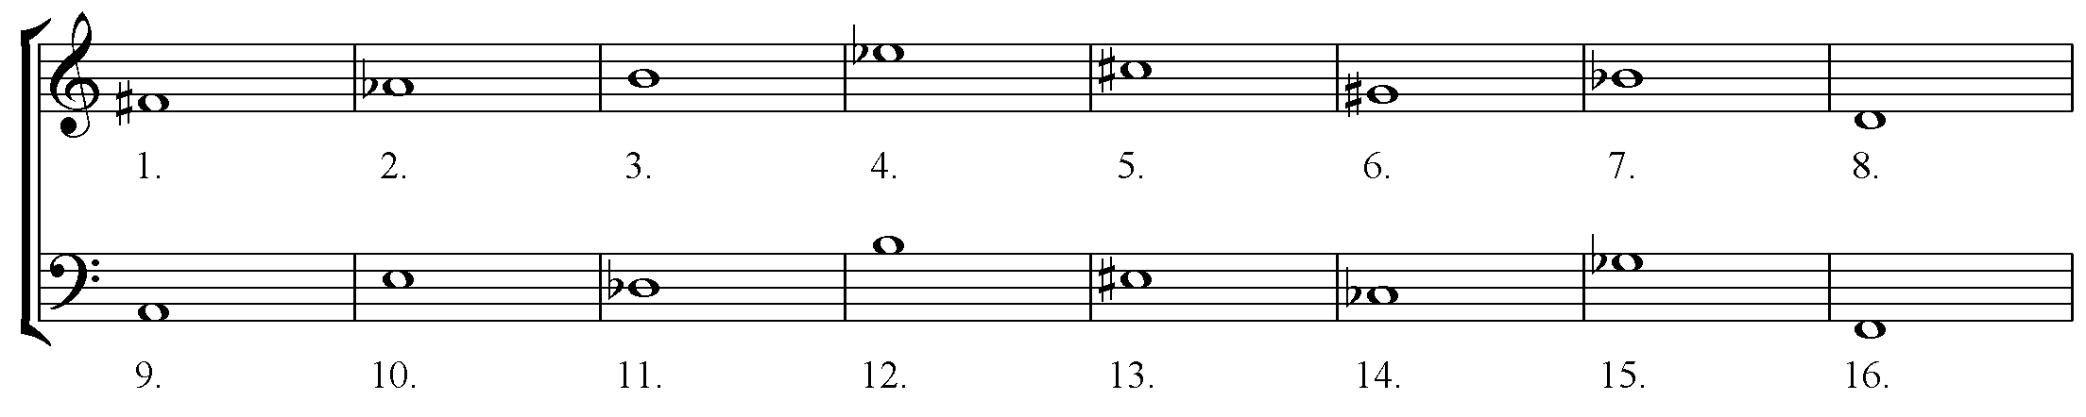
Notate one enharmonic note on the staff next to each given note. Name both pitches.

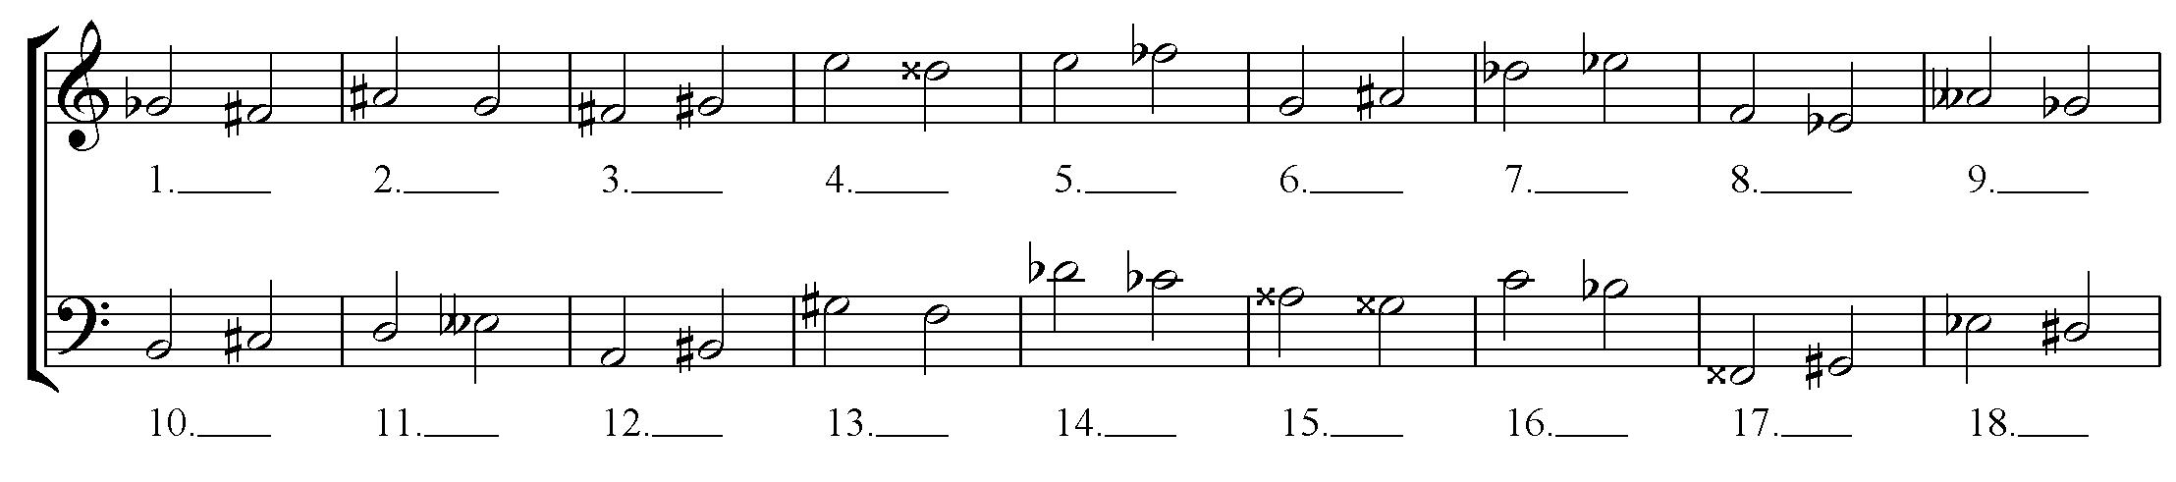
How many steps are between each pair of notes? Answers may be 0, 1/2, 1, or 1 1/2.

