Music Rudiments Name_________________________
Worksheet 2.1
Scales on keyboard

- Write the solfege syllables on the correct keys for the indicated scale. Then notate the same scale on the staff.

  - E major scale
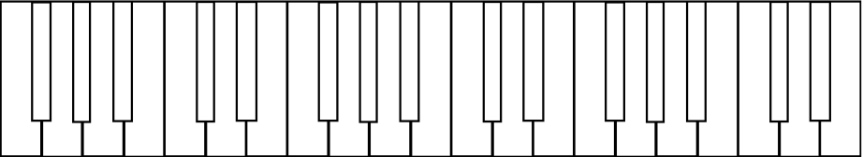

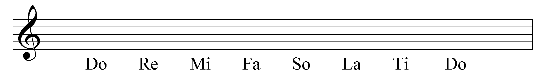

  - Eb major scale

- B major scale

  - Ab major scale

