Music Rudiments Name_________________________
Worksheet 2.2
Key signatures

- Write the solfege syllables on the correct keys for the indicated scale. Then notate the same scale on the staff.

  - Db major scale
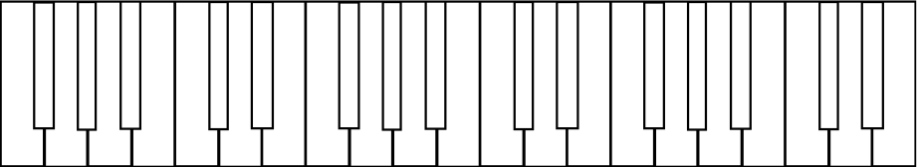

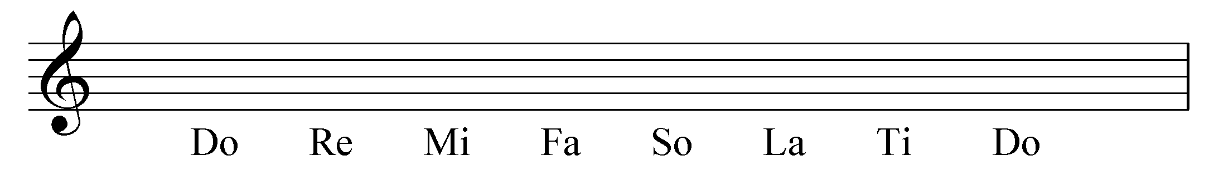

  - B major scale

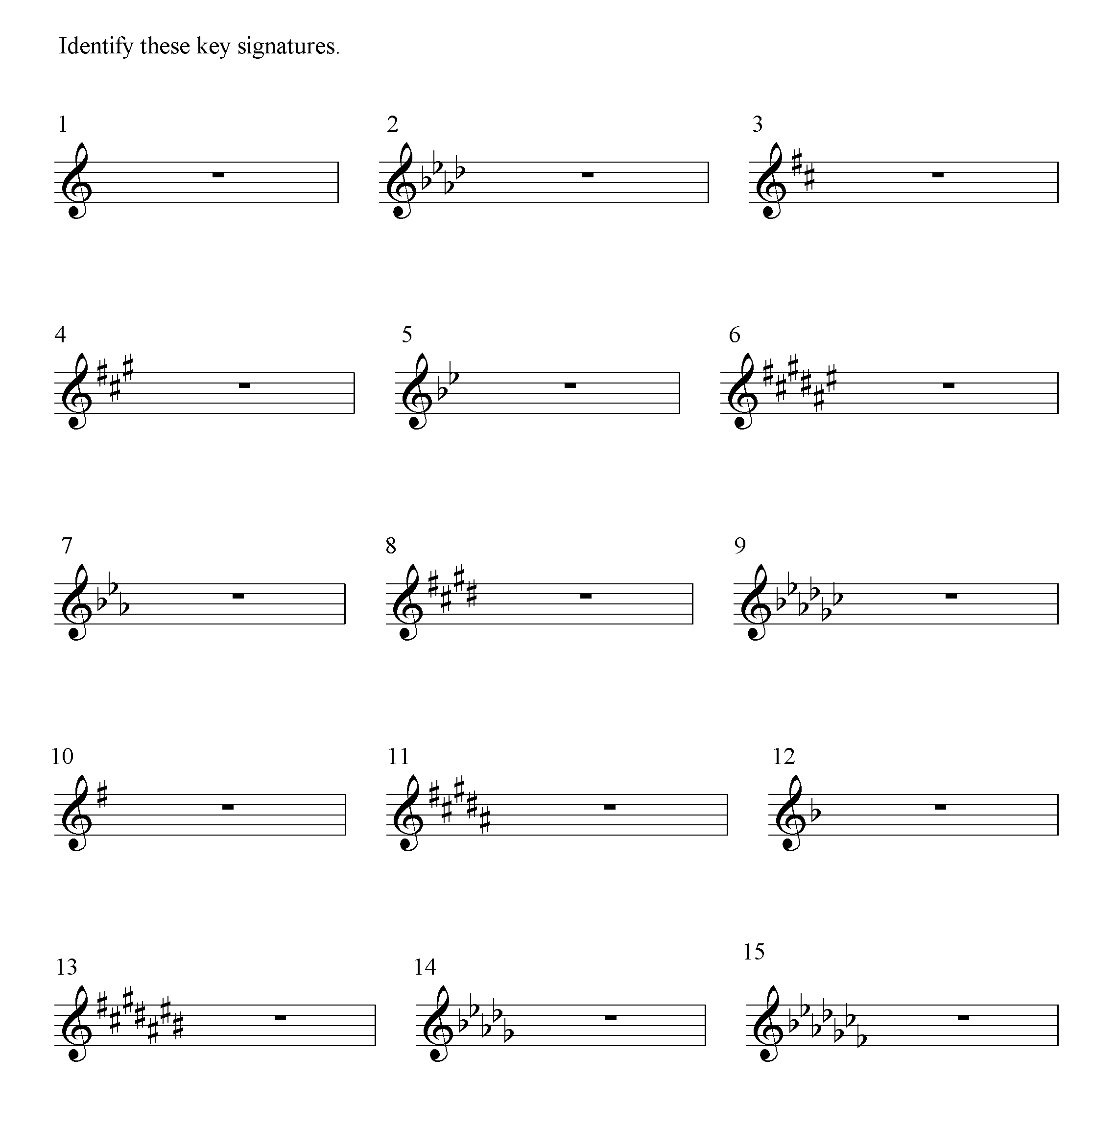
- Identify each key signature.

