Music Rudiments Name_____________________
Worksheet 2.3
Solfege

Identify the following notes with solfege syllables. Observe the changing key signature.
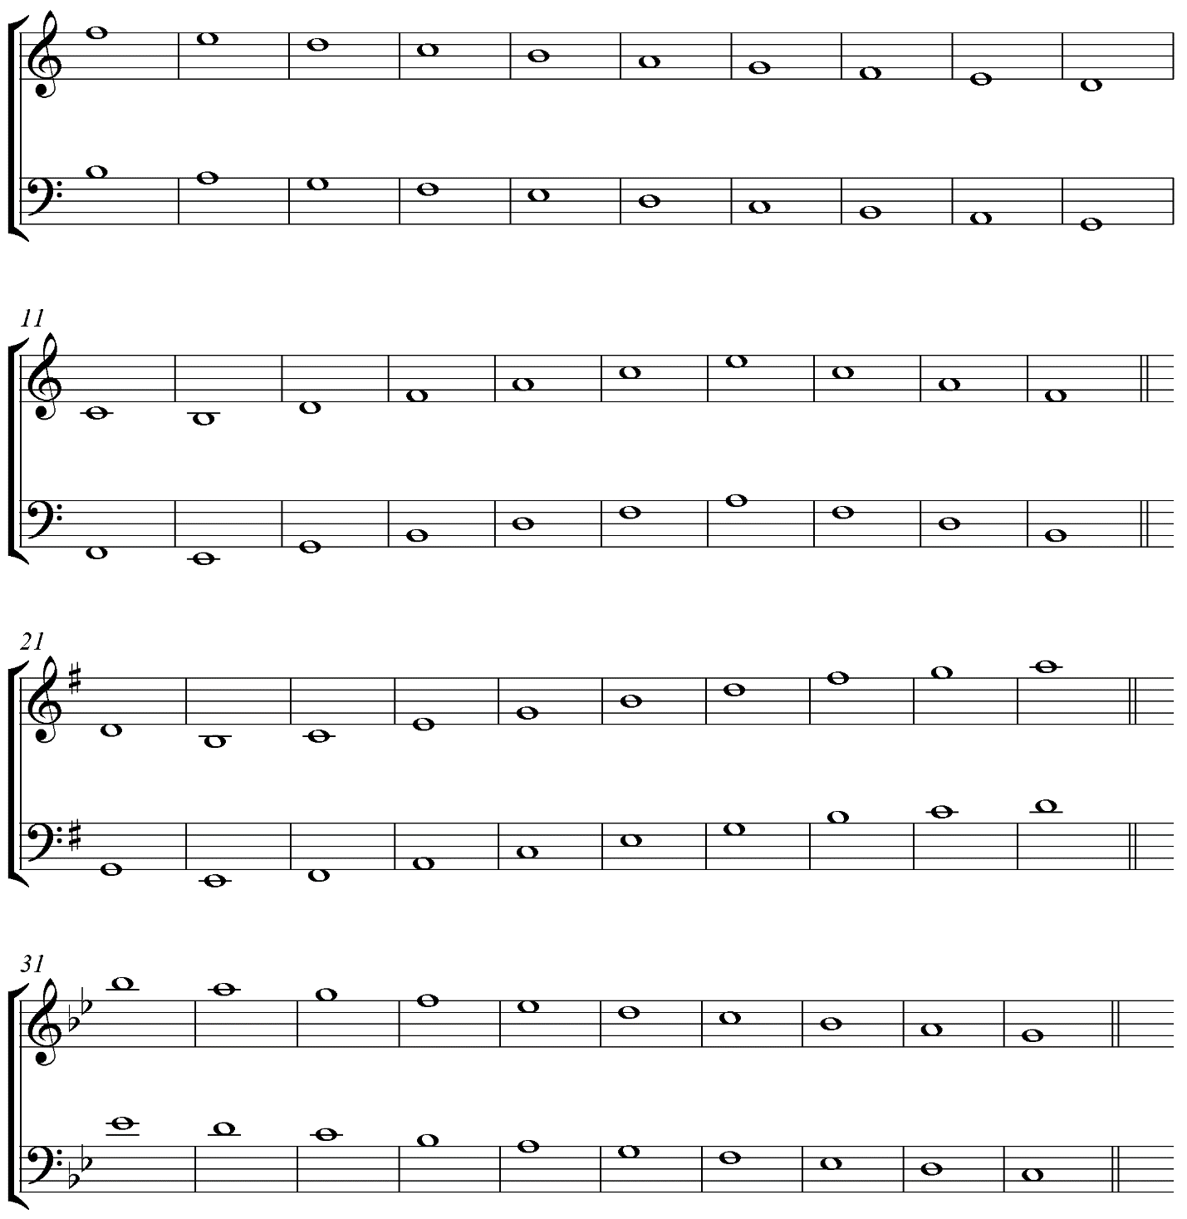

II. Identify the each key signature.
