Music Rudiments Name___________________________
Worksheet 2.5
Chromatic Scale

Supply the missing notes and letter names. Notice the key signatures.
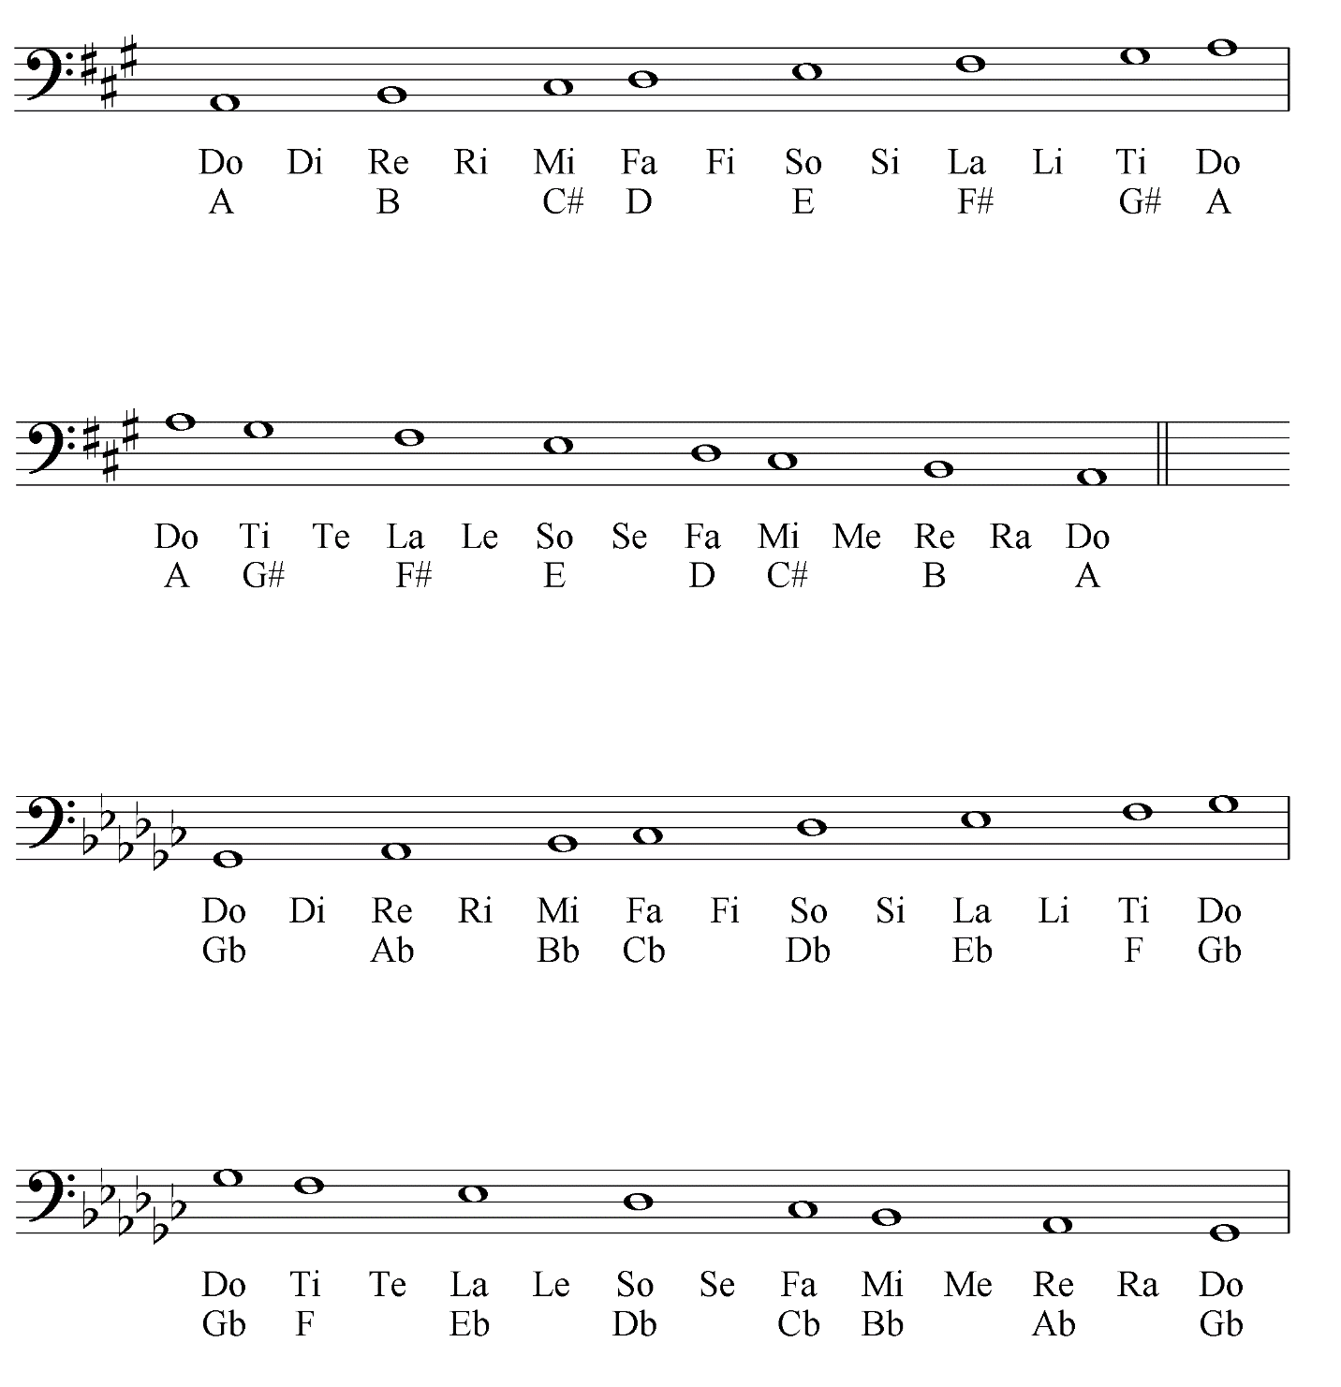

Give the letter name and solfege syllable for each note.
