Music Rudiments Name_____________________
Worksheet 2.6

Supply the missing notes and letter names.
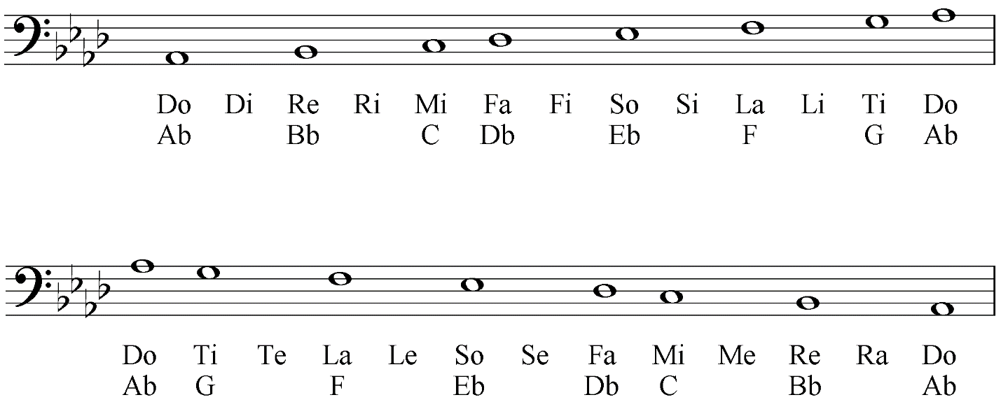

On the top staff (treble clef) notate the indicated note. On the bottom staff (bass clef) identify the given note with solfege.
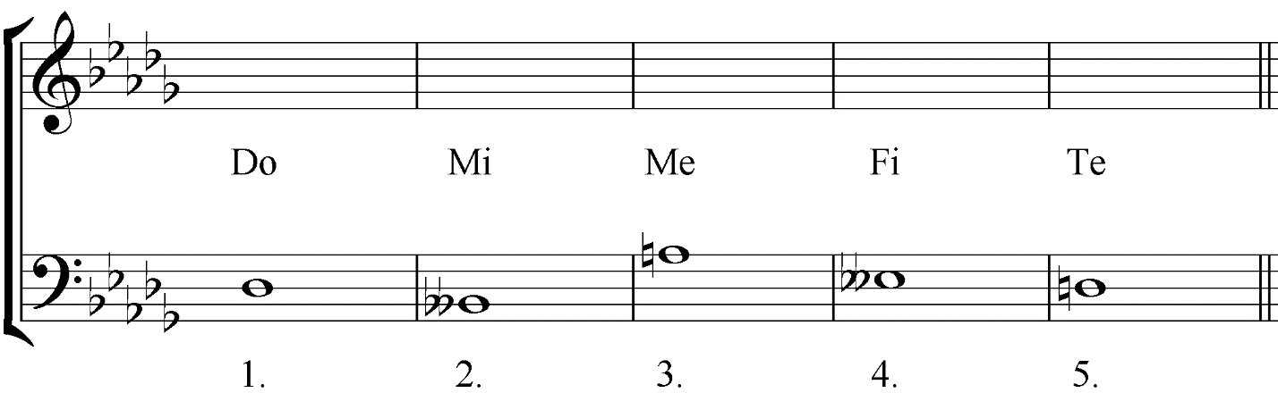

What is the purpose of the key signature? __________________________________________________
_____________________________________________________________________________________

