Music Rudiments Name_________________________
Worksheet 2.7 - review

- True and False
  - (T / F) When a natural cancels a sharp in the key signature it lowers the pitch of a note from what it would be without the natural.
  - (T / F) When a natural cancels a flat in the key signature it lowers the pitch of a note from what it would be without the natural.
  - (T / F) If fa is on B flat, fi will be on B sharp.
  - (T / F) If ti is on E flat, te will be on E double flat.
  - (T / F) La, li, and le will always be on the same line or space in a given key.
  - (T / F) If so is on F sharp, si will be on G natural.
  - (T / F) Key signature sharps and flats apply throughout the whole song in every octave unless they are canceled by a natural or other accidentals.
  - (T / F) The purpose of the key signature is to let the performer know what the key is.
  - (T / F) If the major scale starts on D, its half step/whole step formula will be correct without using any sharps and flats.

- Write the solfege syllables on the correct piano keys for the indicated scale. Then notate the same scale on the staff.

E major scale
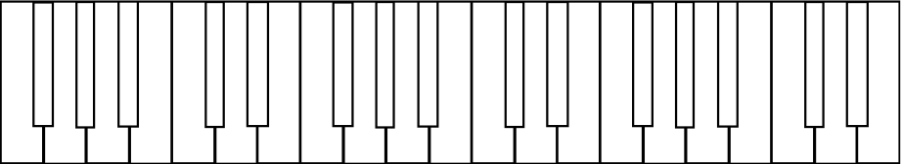

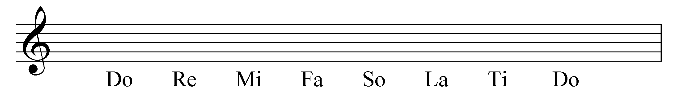

- Fill in the blank.
  - Sharps ________________ the pitch of a note 1/2 step.
  - Flats _________________ the pitch of a note 1/2.
  - Naturals ________________ all previous accidentals.
  - When a major scale solfege syllable is raised in pitch 1/2 step, the vowel of the syllable becomes ____.
  - When a major scale solfege syllable is lowered in pitch 1/2 step, the vowel of the syllable becomes ____, except re which becomes _____.

- Supply the missing notes to complete the chromatic scale. Give the letter name for each note you supply. Do not change the given notes.
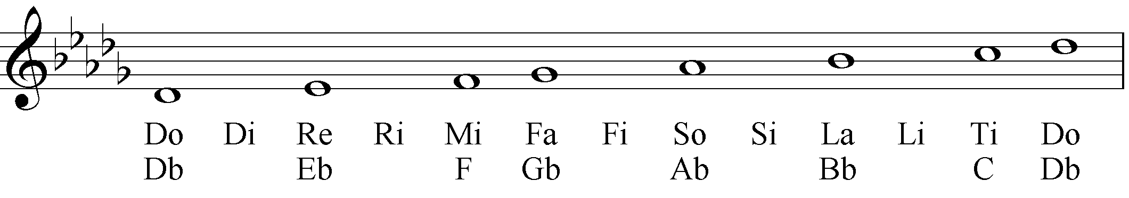
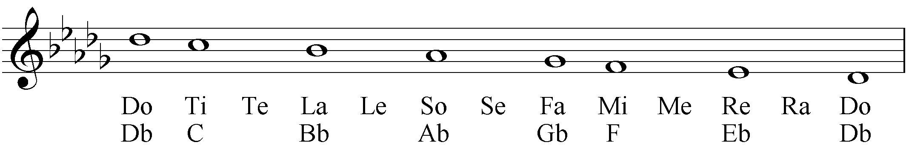

- On the top staff (treble clef) notate the indicated note. On the bottom staff (bass clef) identify each note with the correct solfege.
