Music Rudiments Name_________________________
Worksheet 3.1
Minor Scales on keyboard

- Write the solfege syllables on the correct keys for the indicated minor scale. Then notate the same scale on the staff. Write the solfege names under each note. Remember to start on La.

  - B minor scale
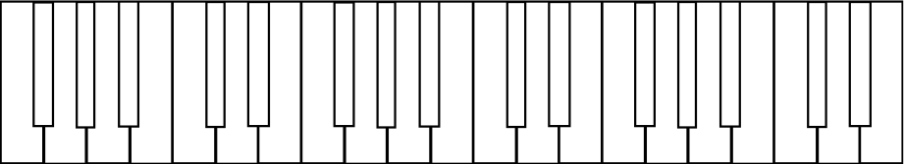

  - Bb minor scale

- C# minor scale

  - F minor scale

  - G# minor scale

