Music Rudiments Name___________________________
Worksheet 3.4
Introduction to intervals

Identify the following intervals by quality and number. All intervals are major (M) or perfect (P).
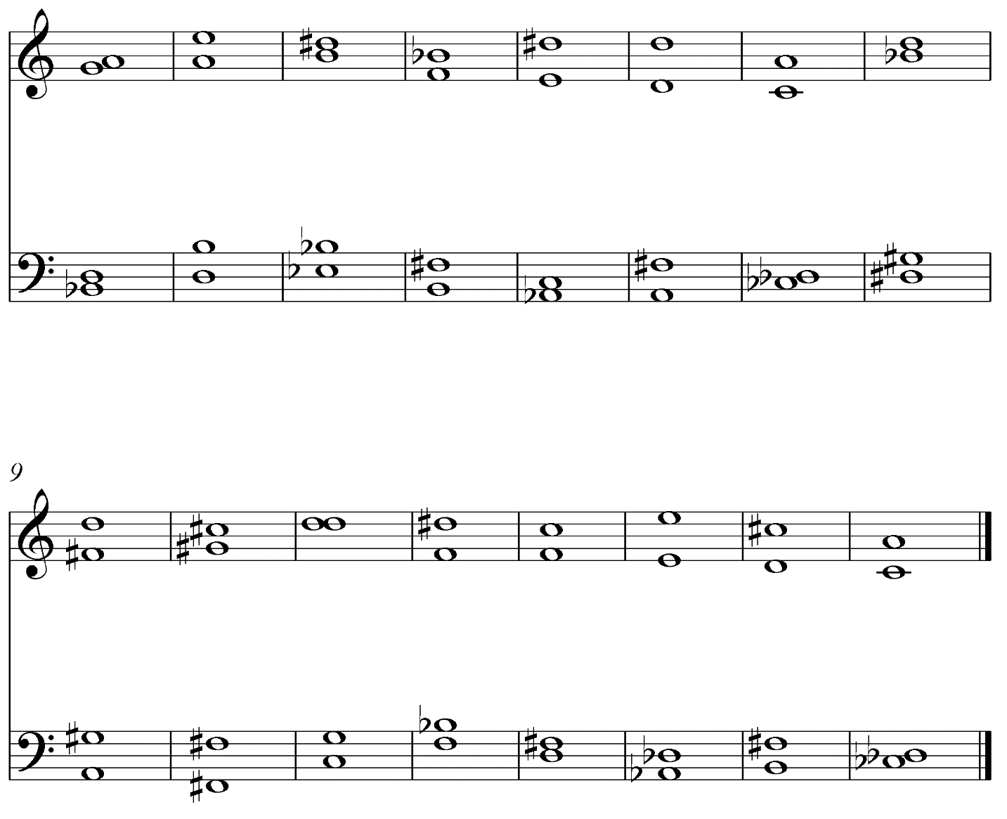
1. 2. 3. 4. 5. 6. 7. 8.
9. 10. 11. 12. 13. 14. 15. 16.
17. 18. 19. 20. 21. 22. 23. 24.
25. 26. 27. 28. 29. 30. 31. 32.

