Music Rudiments Name_________________________
Worksheet 3.5

The following intervals are all perfect or major. Convert the intervals to the indicated quality by changing the top note.

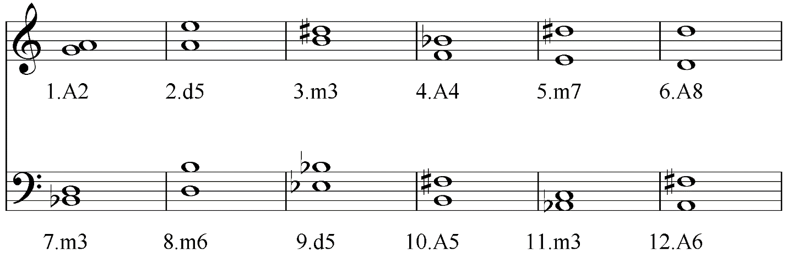

The following intervals are all perfect or major. Convert the intervals to the indicated quality by changing the bottom note.

