Music Rudiments Name________________________
Worksheet 3.7
Intervals of a 2nd and 3rd

I. Identify the following intervals. They are all 3rds.
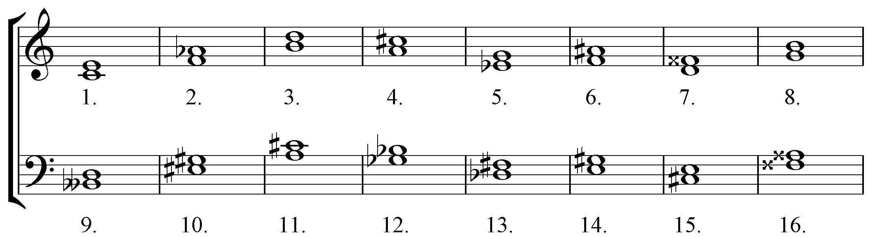

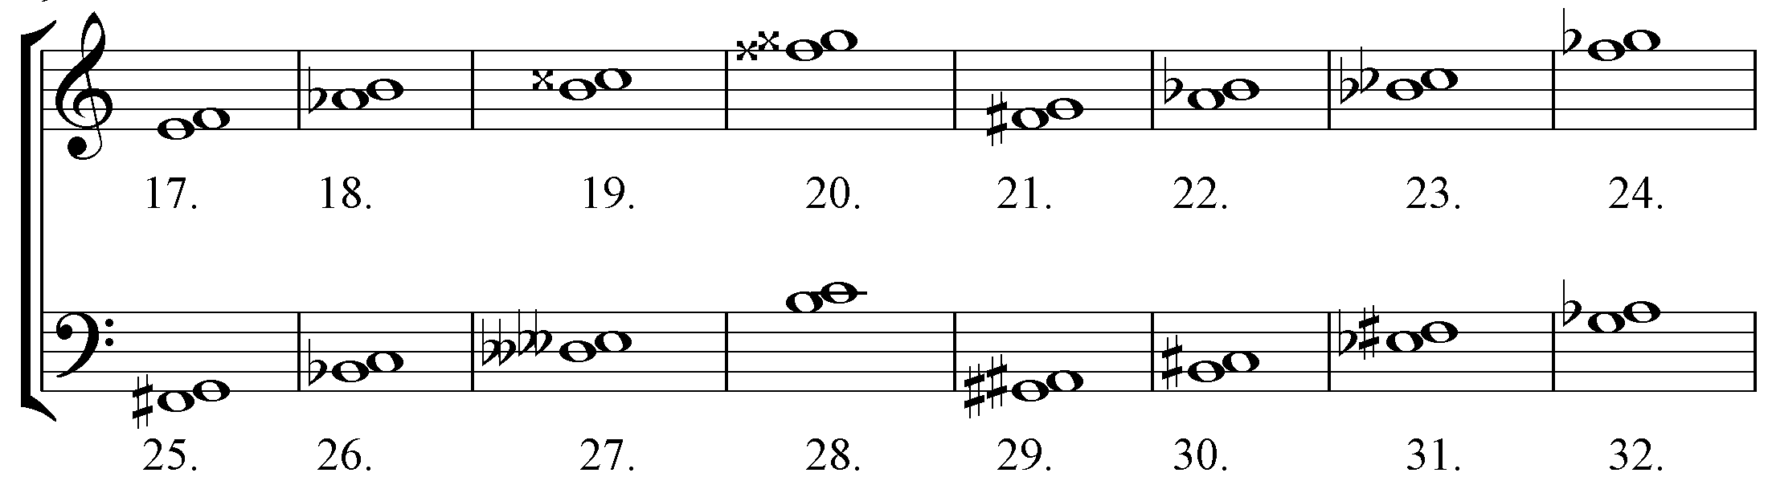
II. Identify the following intervals. They are all 2nds.

