Music Rudiments Name___________________
Worksheet 3.9
Fake Test 3
Minor Scales and Intervals

- Fill in the blank. Answers will be: perfect, major, minor, diminished or augmented.
  - A perfect interval made a half step bigger becomes _________________.
  - A major interval made a half step bigger becomes _________________.
  - A perfect interval made a half step smaller becomes _________________.
  - A major interval made a half step smaller becomes _________________.
  - Intervals of a 4th or 5th will be ____________ if the accidentals match except when the interval is between the letters ____ and ____ (these letters may be switched).
  - 2nds will be __________ if the accidentals match except when going from E to F or _____ to ______.
  - 3rds will be __________ if the accidentals match when the bottom note is on C, _____, or G.

- Identify the following intervals.

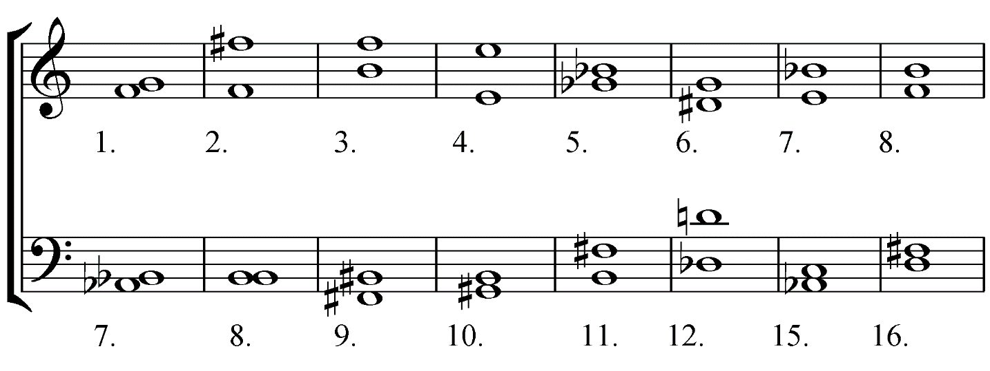

- Notate the indicated interval above each note.

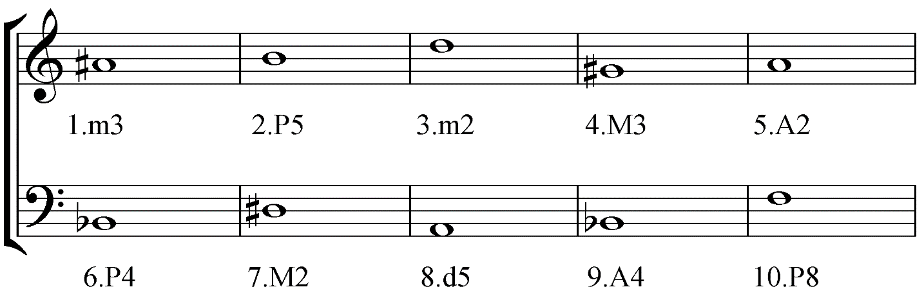

- Build a minor scale starting on the given note. Identify solfege and mark half steps.

- What is the key of each of the following melodies? Answers will be a letter with a possible accidental, and the word major or minor.

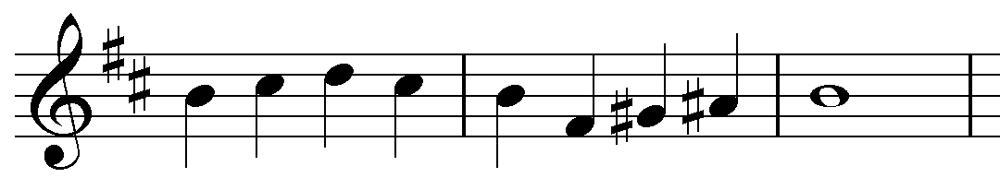

Key: _____________________

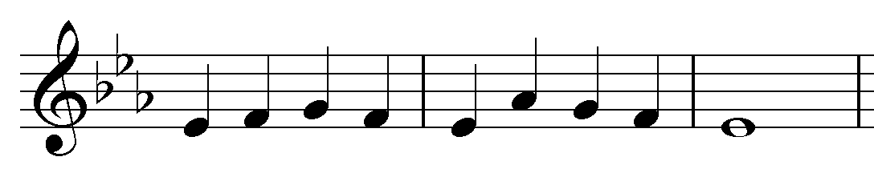
Key: _____________________

