Music Rudiments Name_________________________
Worksheet 4.2
Identifying triads with lead sheet notation

Identify the following triads using lead sheet notation.
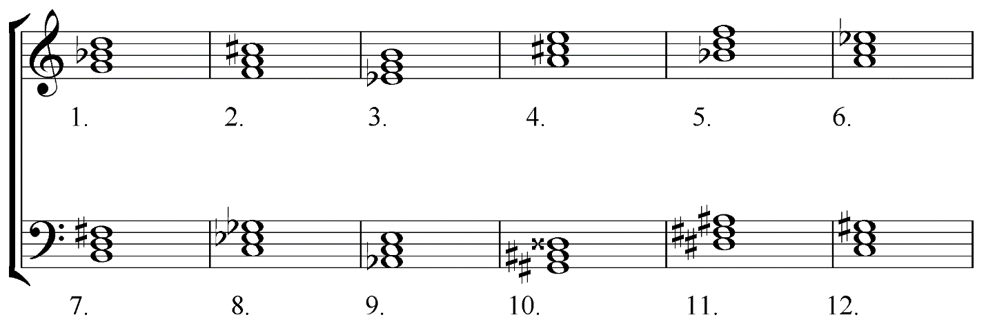

Construct the indicated triads.
