Music Rudiments Name___________________________
Worksheet 4.4
Lead Sheet with slash notation

- Identify using lead sheet notation and slash notation.

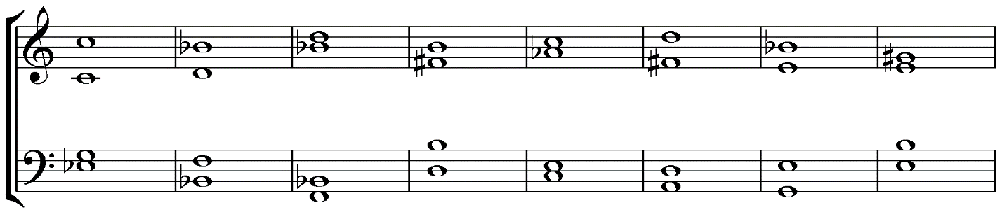
1. 2. 3. 4. 5. 6. 7. 8.

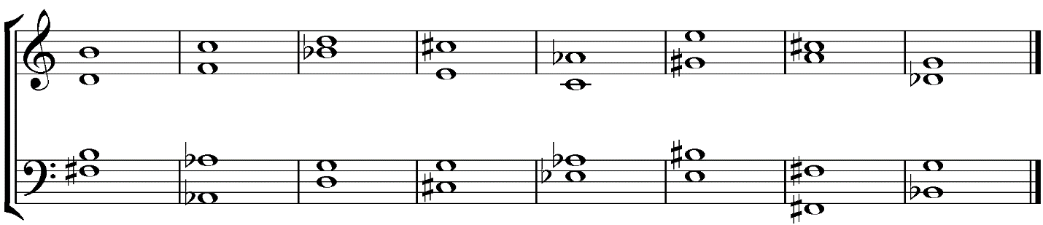
9. 10. 11. 12. 13. 14. 15. 16.

