Music Rudiments Name______________________________
Worksheet 4.4
Lead sheet with key signatures

Identify the following chords with lead sheet and slash notation.

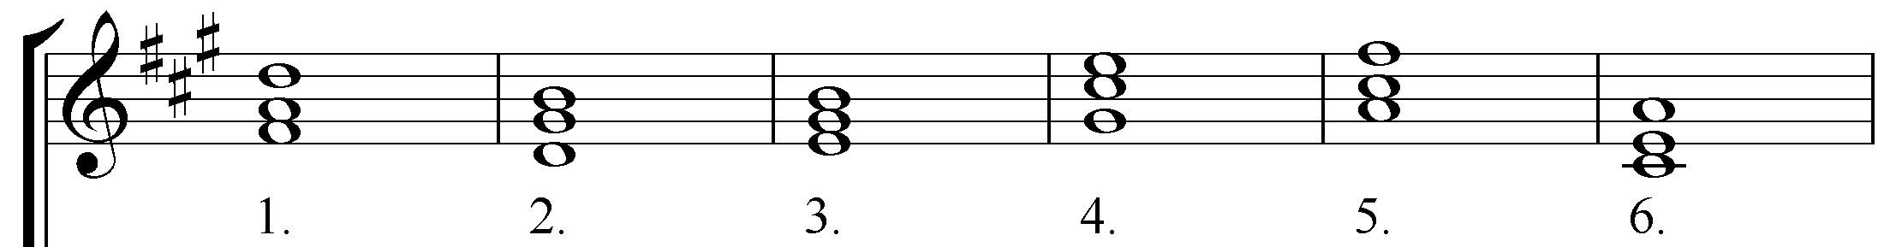

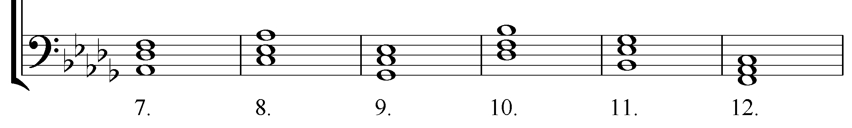
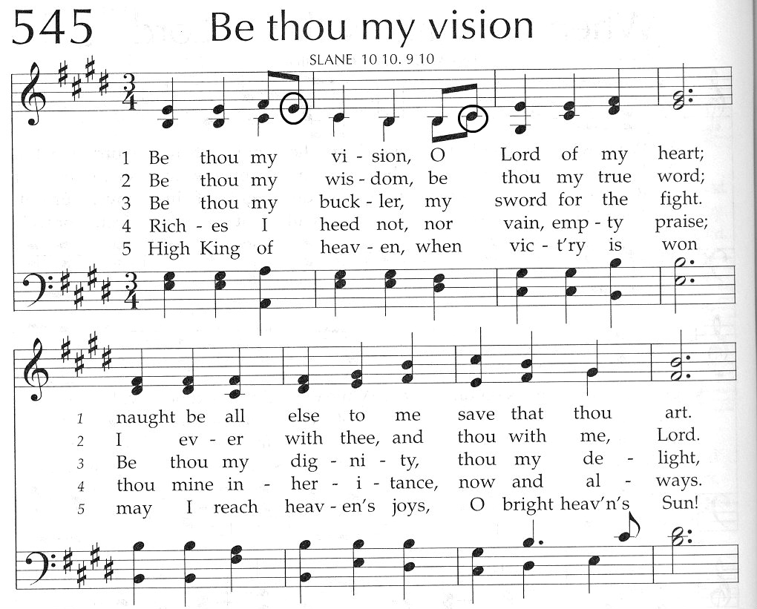
1. 2. 3. 4. 5. 6. 7. 8. 9. 10.
11. 12. 13. 14. 15. 16. 17. 18. 19. 20. 21.
Identify each chord with lead sheet and slash notation. Ignore the circled notes.

