Music Rudiments Name___________________________
Worksheet 4.5
Realizing Lead Sheet notation

- Notate the chords on the staff as indicated by the lead sheet notation.

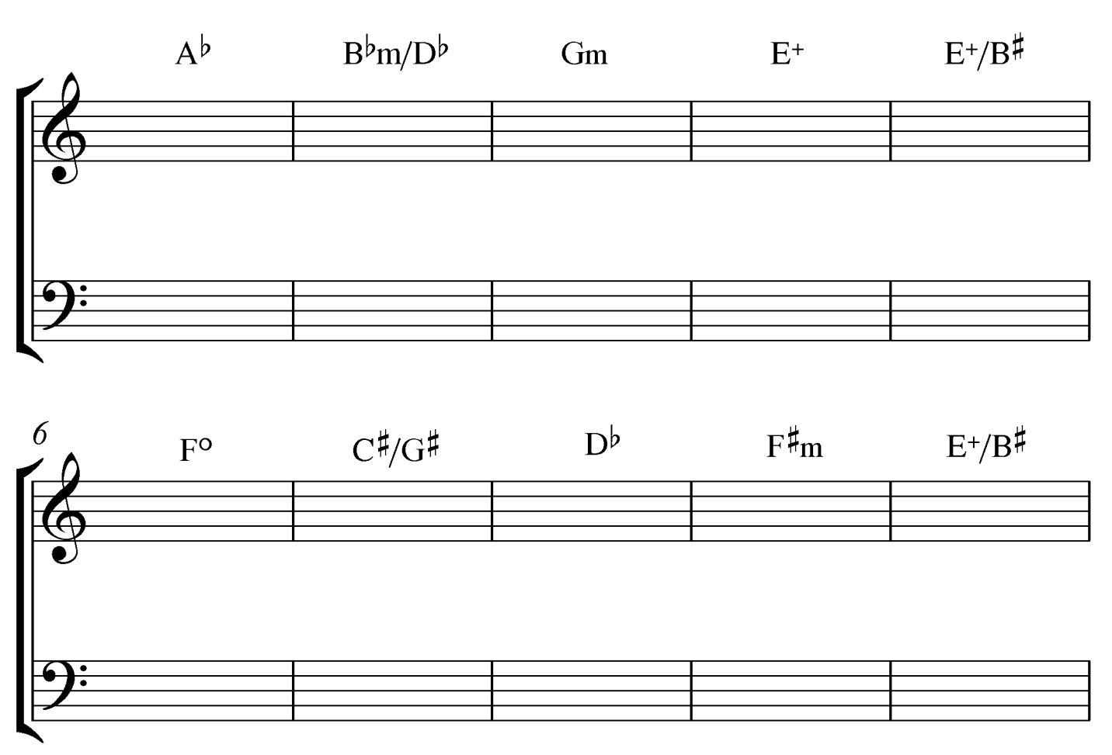

- Place correct count under each note. For rests, place count in parenthesis.
