Music Rudiments Name______________________________
Worksheet 4.6 - Roman Numerals

I. Identify each triad using lead sheet notation.
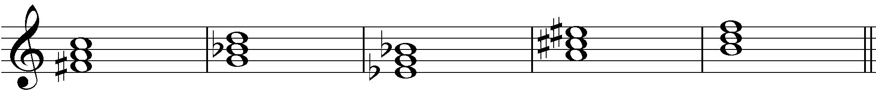
1. 2. 3. 4. 5.

II. Above the staff, identify each triad using lead sheet notation. (Don't forget about the sharps in the key signature.) Below the staff identify each triad using Roman Numeral analysis.

Lead Sheet: 1. 2. 3. 4. 5.
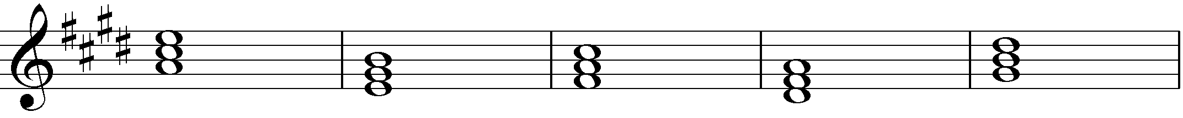
Roman 1. 2. 3. 4. 5.
Numerals

III. Identify each triad using Roman Numerals.

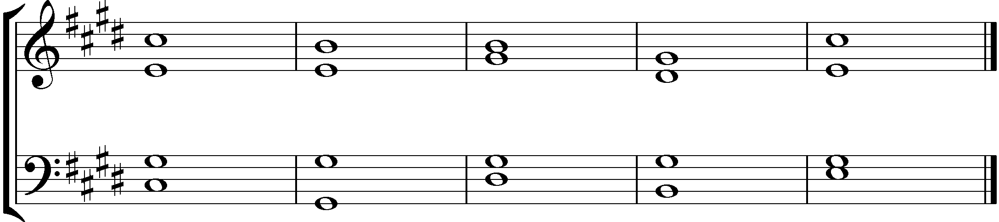
1. 2. 3. 4. 5.

