Music Rudiments Name______________________________
Worksheet 4.7
Roman Numeral analysis of a hymn

- Analyze each chord using Roman Numerals. Ignore the circled notes.

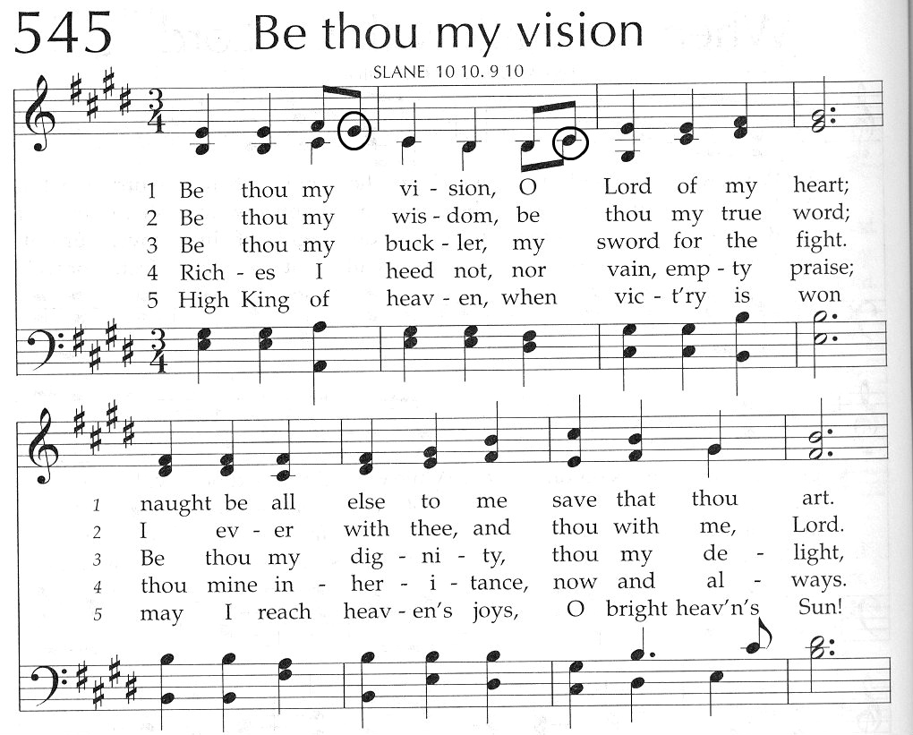
1. 2. 3. 4. 5. 6. 7. 8. 9. 10.
11. 12. 13. 14. 15. 16. 17. 18. 19. 20. 21.

- Place correct count under each note and rest. Put parenthesis around counts under rests.

