Music Theory Name_________________________
Fake Test 4 – triads and compound time

- In each box, identify the intervals that make up each triad quality. Answers will M3 or m3.

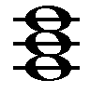

Major Minor Diminished Augmented

- Identify the quality of each triad. (M, m, d, A)
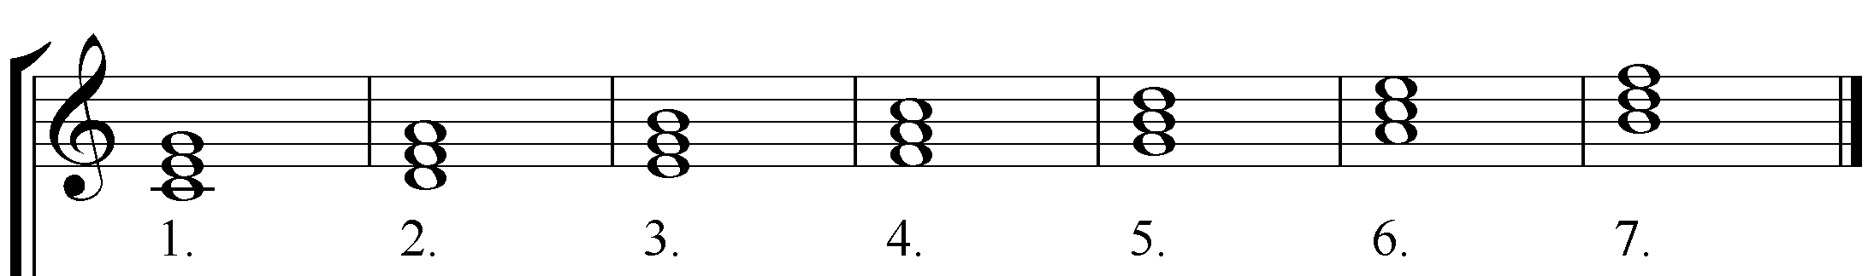

- Fill in the blank.
  - Triads built on the roots _____, _____, and _____ will be major if no accidentals are added.
  - Triads built on the root B will be _______________ if no accidentals are added.
  - A song is probably in compound time if the ______ number of the time signature is ______ or higher and divisible by ______________.
  - The primary difference between compound time songs and simple time songs is that the division of the beat for compound time songs is in ___________ rather than in __________.
  - When a song is in 6/8 time, which note is usually worth one beat? ____________________
  - In compound time how can you figure out which conducting pattern to use? ________________________________

- Place the correct count under each note and rest. For rests, place the count in parenthesis.
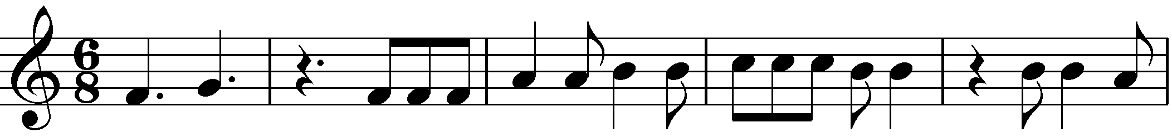

- Construct the triads indicated by the lead sheet symbols.
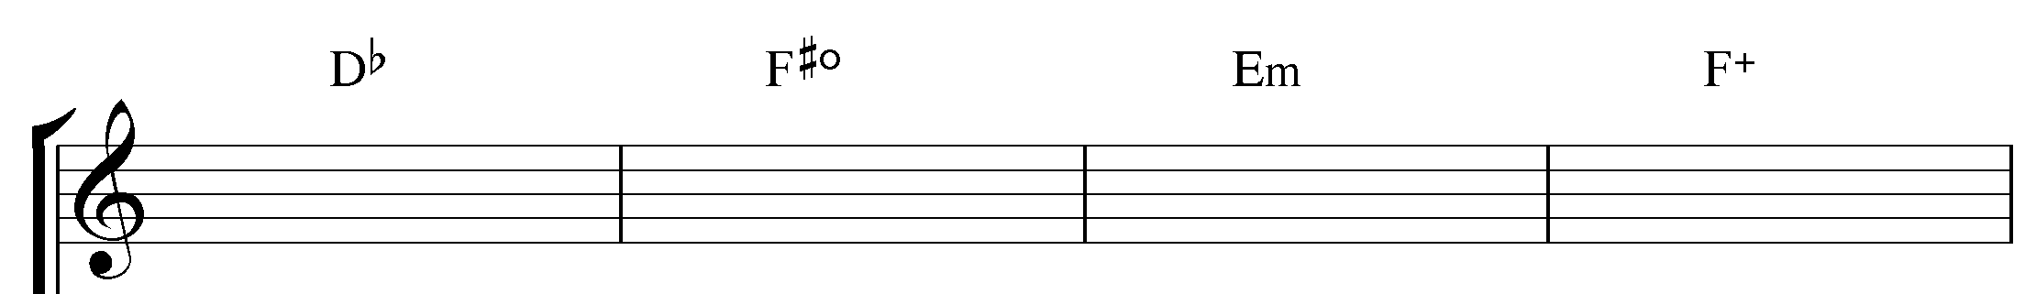

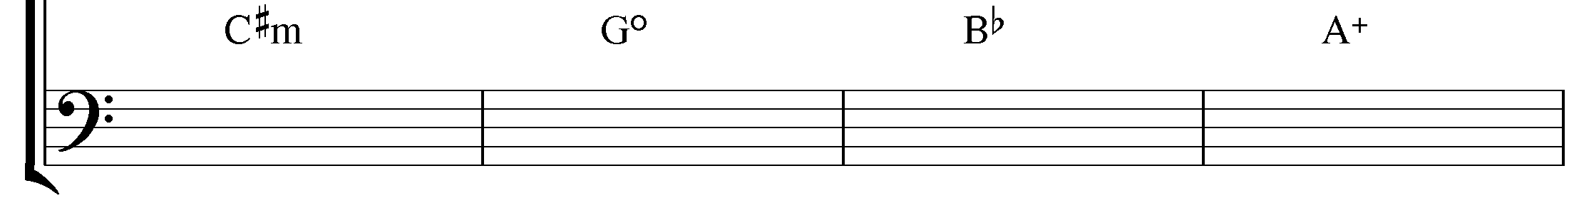

- Identify the following triads with lead sheet symbols. Include slash notation when bass does not have the root of the triad.
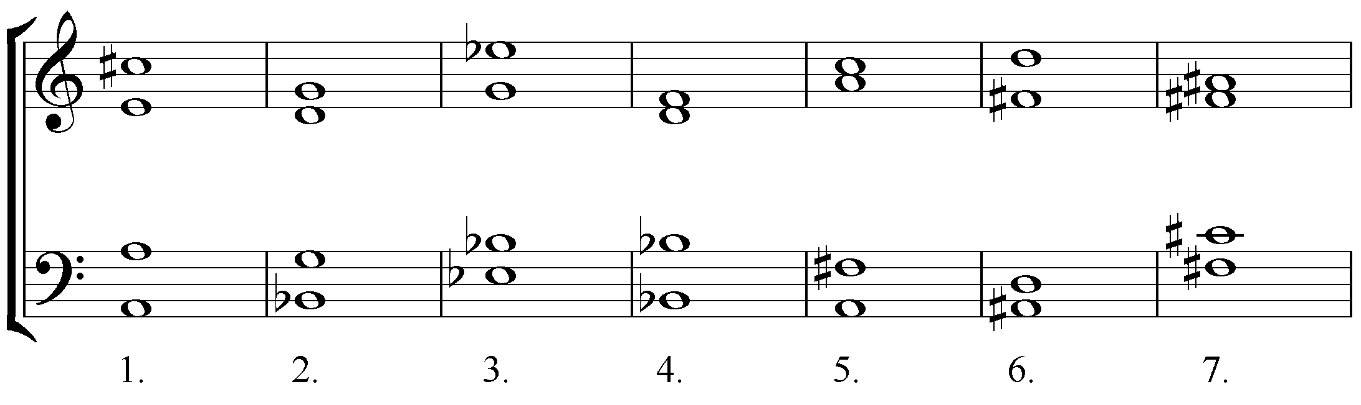

V. Identify the following triads with Roman numerals.
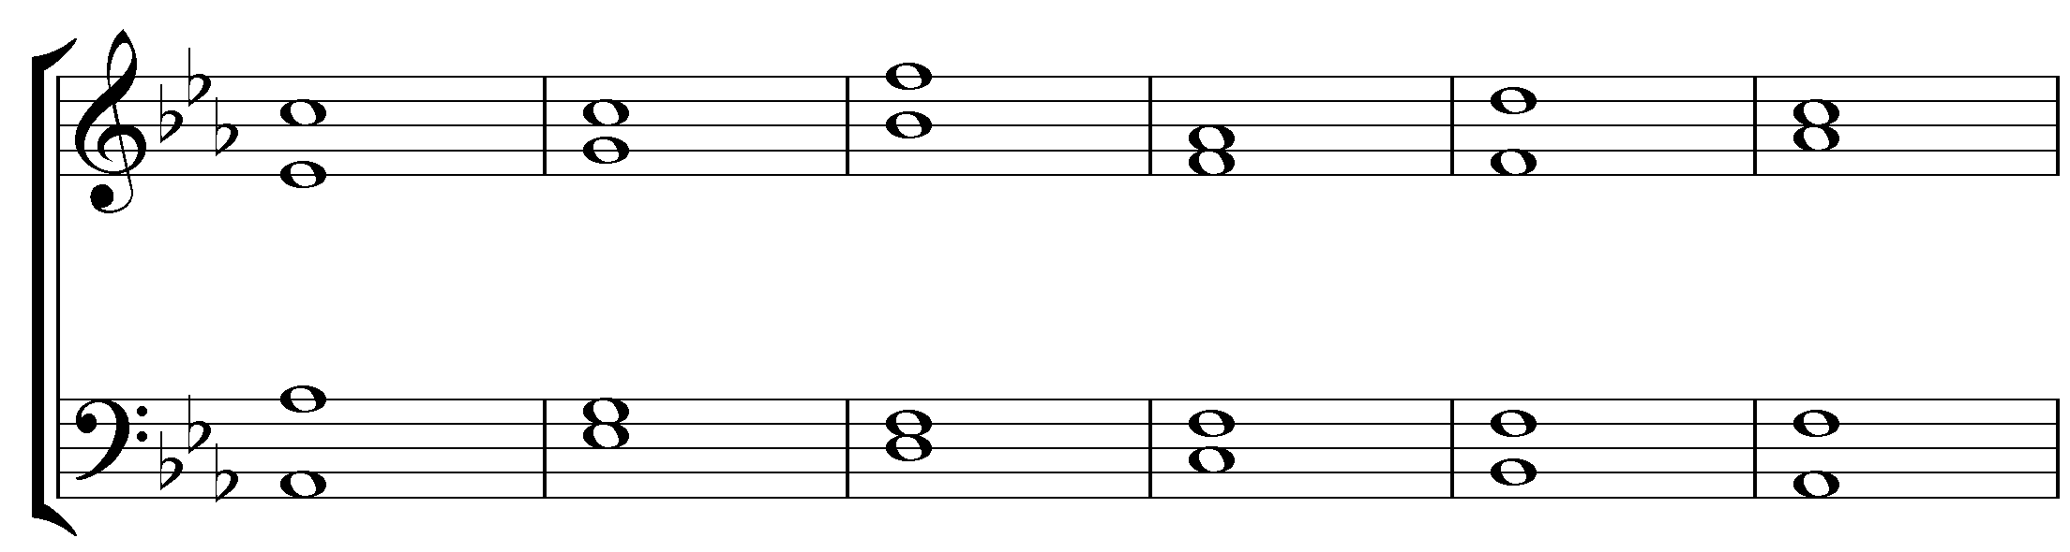
Roman Num: 1. 2. 3. 4. 5. 6.

